21st September 2020

Dear Parents and Carers

I am surprised by how quickly the last two weeks have gone by. I would like to express my sincere thanks to you all for your ongoing support to the school during these challenging times and your patience as we continue to make slight changes to arrangements at drop off and pick up times.

Social distancing
We continue to receive concerns from parents about the lack of social distancing, particularly in the afternoons when children are being collected from school. In order to ensure everyone feels safe please can everyone;
- Be aware of others around them and keep at least one metre apart
- Wait for your children where the class signs are placed; this is usually one class against one side of the gate and the other class at the opposite side.
- Wear a face covering.
- Avoid lingering after children have been collected
If we all work together we can help everyone feel more comfortable when collecting their children.

Access to testing
As you’ve probably seen in the News, getting access to tests can be challenging. If you are trying to get a test, access is through the website and you just have to keep refreshing the page. It is important to confirm the presence of symptoms. If there are no symptoms it is unlikely to be given a test. Hopefully this will become easier in the coming days and weeks.

When to isolate
Every day we are being asked when to self-isolate. This link https://www.nhs.uk/conditions/coronavirus-covid-19/self-isolation-and-treatment/when-to-self-isolate-and-what-to-do/ is a useful go to for this information. If your child has a ‘runny nose’ they can still come to school. Symptoms of Coronavirus are one or more of the following;
- A new persistent cough
- High temperature
- Change to sense of taste and smell

Hands, Face, Space
- Wash your hands regularly
- Wear a face covering
- Make space by keeping a safe distance

Please be aware that the office staff are not medically trained and cannot advise you on whether your child should be in school or not, please use the link above or call 111 to seek medical advice.

Parking
We appreciate that the start and end of the day is busy around the school. Please can parents refrain from blocking the staff carpark near the park. We have had staff unable to get out because people have parked across them. Can we all consider local residents if parking along the roads. Thanks for the support with this matter.

Attendance
It is essential children come to school regularly. Research has shown that children who attend school regularly are more settled and likely to achieve their full potential. We continue to closely monitor attendance. If you think we may need help with this, please contact Mrs Green - we are happy to offer support in any way we can.

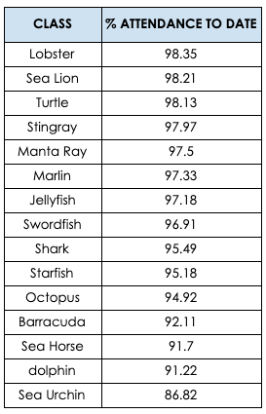

Office Information
Keeping contacts up to date
Please be reminded to keep the school up to date with your contact details i.e. phone numbers, addresses, adding or removing contacts for collections, email addresses (if mobile number and/or emails are changed please also update these via Parentpay) Email the office on officeadmin@leightonprimary.net

Medical
Previously, Medication, asthma inhalers etc were received through the office. However, due to the current climate, please obtain medical/asthma inhaler permission forms via email from the class teacher and then returned via class and not through the office to reduce contamination.

Forgotten items
Unfortunately, we are unable to receive forgotten items through the office that are needed for children in classes, this is to reduce transmission of Coronavirus

Parentpay Updates
Any items (ties, bottles, bags) that have been purchased via Parentpay will be arranged to be received in class on a Friday morning, ready to bring home that afternoon.
Please ensure your child’s dinner account is in credit if they wish to purchase lunches.

Dates for your diary
- 25th September - National day of European languages
- Children are going to come to school wearing the colours of the country they will be learning about that day
- Week Beg 2nd November - parents evening. We will be in touch soon with further details on how this will be organised.
- 13th November - Tempest whole school photography in
- 3rd December - Whole school flu vaccinations

Kind regards
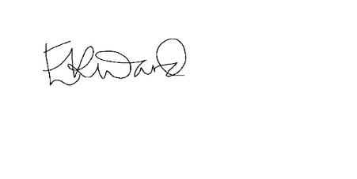
Mrs Emma Ward
Headteacher

