A free write based on this picture (or your own choice). You could write a story, a letter, make a cartoon, or write a guide to looking after dragons.
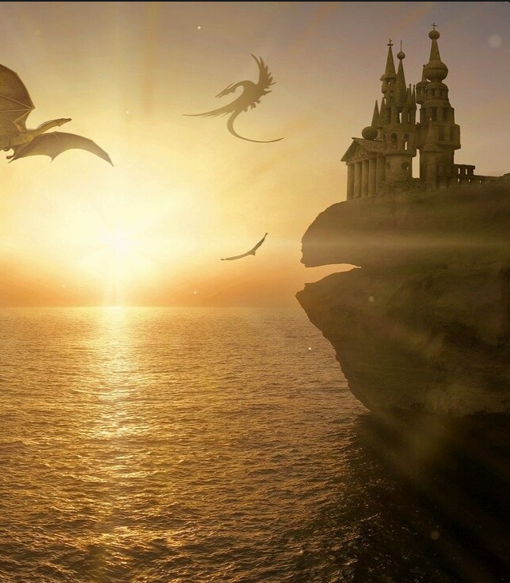
If you need help, you could use this story starter to help you begin… or these sentence starters… or key words… or questions…


