Leighton Primary & Pre School - Children working at home (leightonprimaryschool.co.uk)

Use the above page on our school website for more Year 3 learning, particularly on learning Time and Fractions, and Cleopatra.
This information is at the bottom of the page under: Main Learning Focus for Today.

Here are some learning activities for today Monday 19th June

Arithmetic

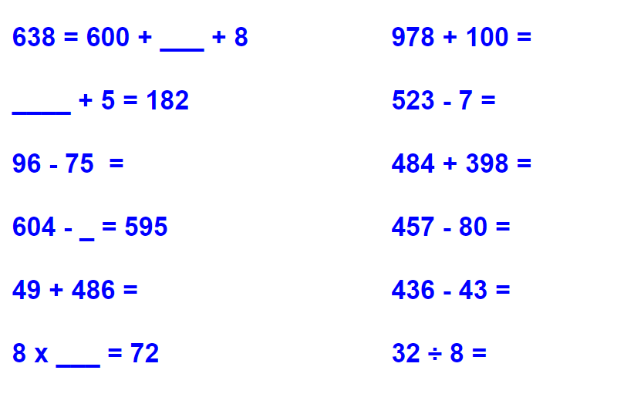

If you get stuck, use a method you know like column addition or column subtraction, or a numberline.

Use these websites to practice the times tables you are learning.
Choose from x10 x2 x5 x3 x4 x8 x11

Practice quick recall of answers:
Hit the Button - Quick fire maths practise for 6-11 year olds (topmarks.co.uk)

If you are learning a times table, use this website:
Times tables games - Learn them all here!

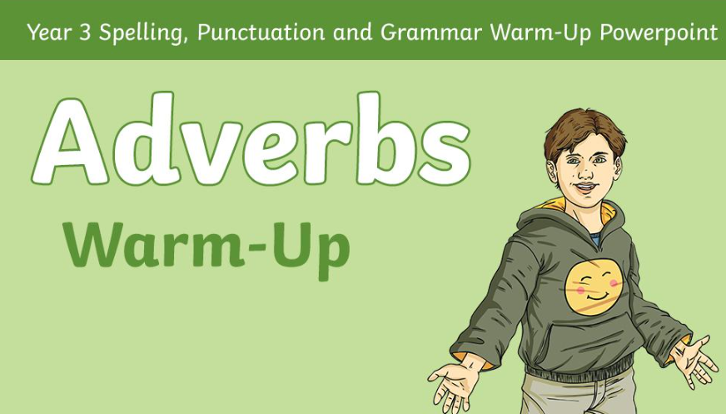
Grammar

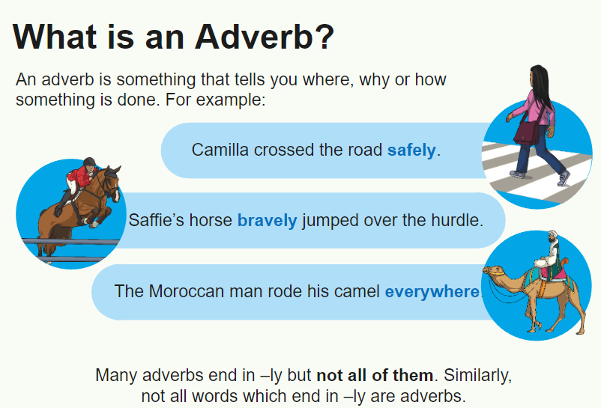

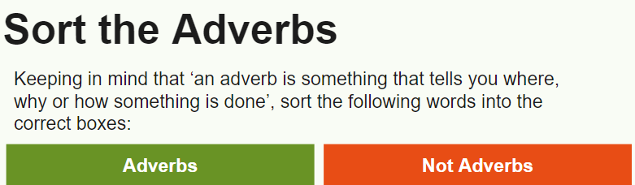

Sort the following words into 2 lists; adverbs and not adverbs.
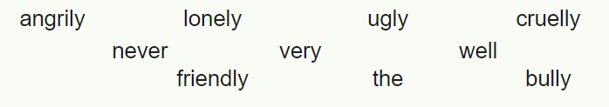
Can you think of any more adverbs?

Adverb spotting: Find 3 adverbs in a book you are reading.
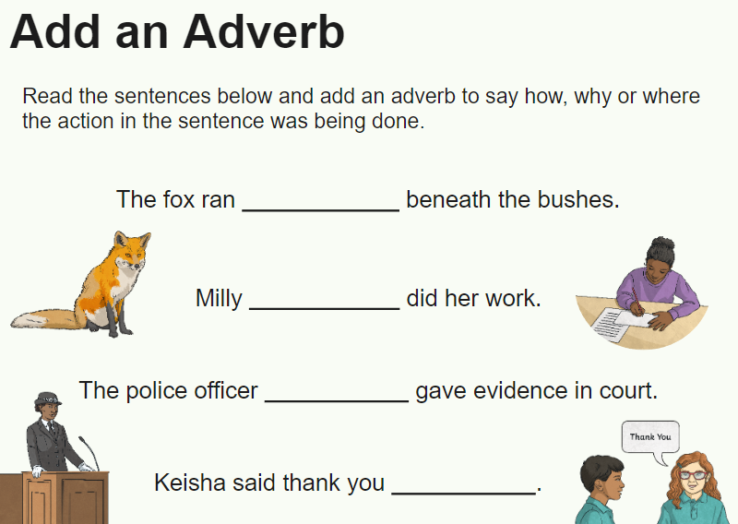

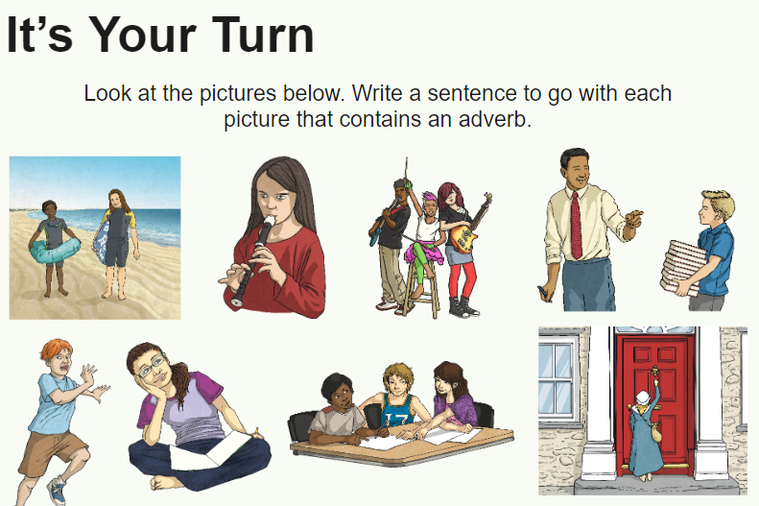

Choose 3 pictures to write a sentence about. Make sure each sentence has an adverb in it!

Science

SCIENCE WEEK STARTS TODAY!

Click on this link to find out about Science Week.
Leighton Science Week Connections 2023 (2).pptx - Google Drive

This link takes you to a webpage showing many different scientists. Scroll down to the bottom of the page and choose some short videos to watch.
Smashing Stereotypes: The profiles - British Science Week

What sort of scientist would you like to be?
Choose one scientist’s job to research.
What can you find out about this job?
What do you need to be good at? What skills do you need?

Read about Marie Curie and answer the questions below.



