Good morning!

Here are some learning activities for today Tuesday 20th June
Please remember to read your books and write in your diaries!

Arithmetic

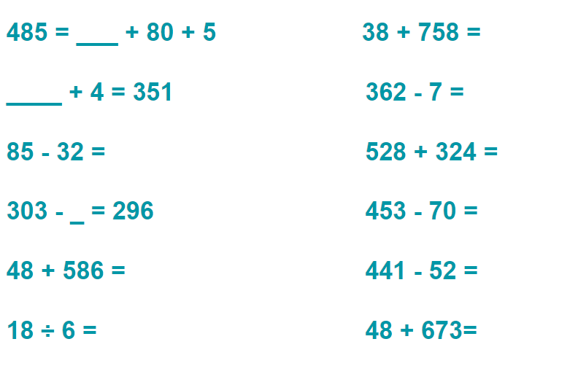
Use these websites to practice the times tables you are learning.
Choose from x10 x2 x5 x3 x4 x8 x11

Practice quick recall of answers:
Hit the Button - Quick fire maths practise for 6-11 year olds (topmarks.co.uk)

If you are learning a times table, use this website:
Times tables games - Learn them all here!

English and Art

Please watch this clip of an erupting volcano.
Mount Etna - Google Search

Join in with the draw along to draw a volcano.
How To Draw A Volcano - YouTube

Now write words or phrases to describe a volcano, such as fiery or explosive.
You can describe the heat, colours, actions, size and anything else you notice.
You might think of a simile …as ….. as a ……

Please bring these words and your drawings into school.

If you want to learn more about volcanoes, watch this video.

Information video about the three different types of volcano
Check Out Our Favorite Educational Volcano Videos for Kids (weareteachers.com)

Maths Time

This lesson is about am and pm. Please see the activities below.

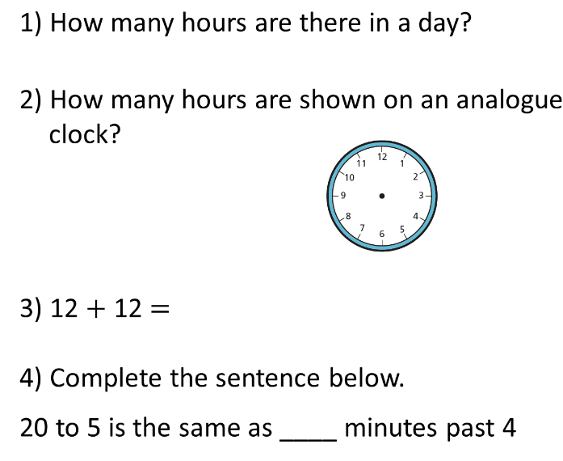
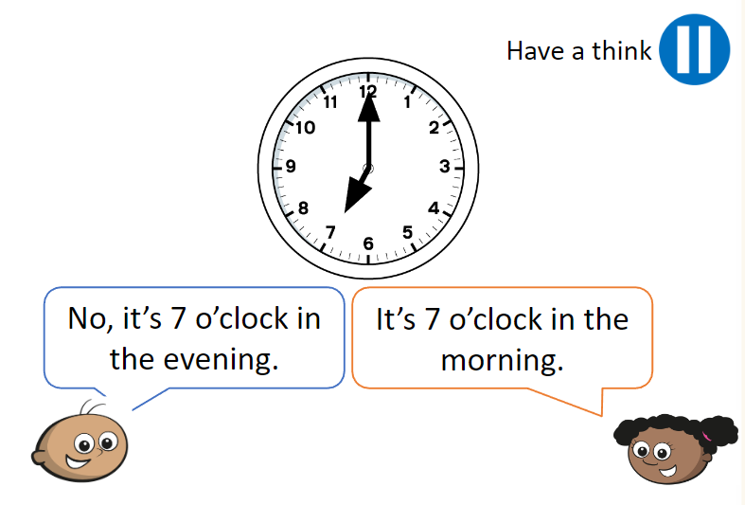
Who is right? Could they both be right?
If so, why?

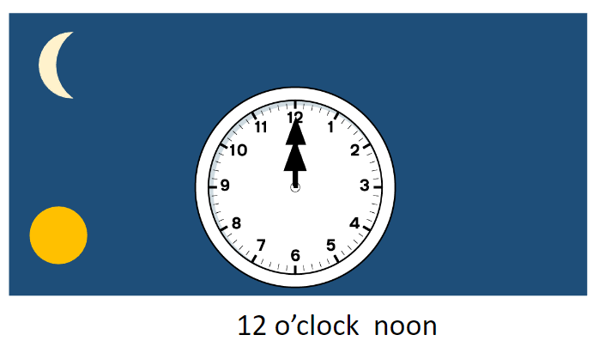
12 o’clock midnight

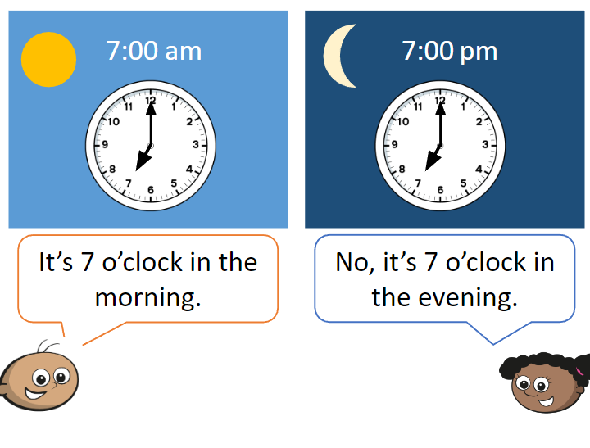

We need to use am to show that a time is during the first 12 hours of a day and pm to show that it is during the last 12 hours of a day.

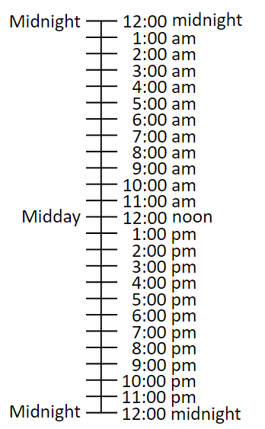

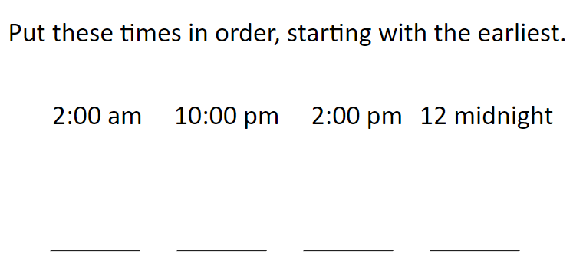

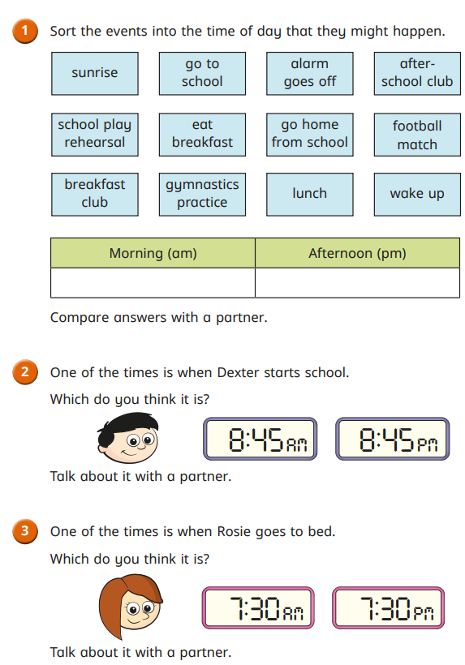

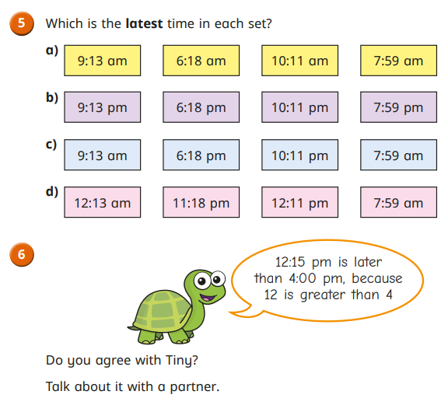

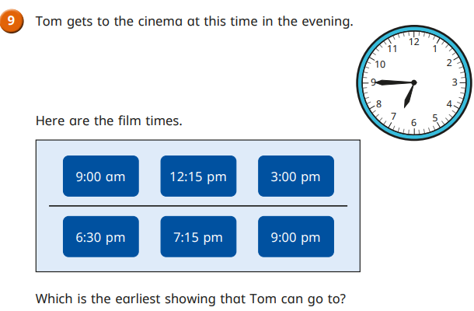

French
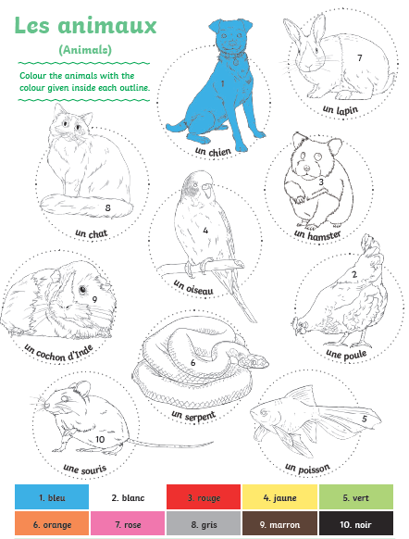

If you can’t print this at home, can you draw the animal, label it and then colour it with the correct colours. Don’t forget to say the names and colours out loud to practice your French!
♫ La Chanson des Couleurs ♫ French Colors Song ♫ Les Couleurs en Français ♫ Learn French Basics ♫

Reading


