The world of work can be split into different categories.

Industry is what we call making things. Employment is another word for a ‘job’, and jobs can be said to be either primary, secondary, tertiary or quaternary roles.

Primary roles obtain natural or raw materials. Examples include agriculture, forestry and fishing.

Secondary roles use the materials produced by the primary industries. Examples include manufacturing, food processing, oil refinery and energy production.

Tertiary, also called the service sector, involves selling or services and skills.

Quaternary roles provide information services, for example computing, ICT, consultancy or research and development.

Can you work out which is which in the pictures below?
Key takeaways
- The way we have lived for the last 200 years can no longer be sustained. Rapid material growth has caused untold damage to the Earth. Humans have dug up raw materials, built over natural habitats and constantly dumped waste, damaging the planet on which all life depends.
- Rather than trying to work within the Earth’s natural systems, development has gone on with little regard to the Earth’s systems. Consequently, the atmosphere and the seas are warming up, the glaciers are melting and sea levels are gradually rising. These are all environmental issues.
- There are all sorts of ways you can improve older buildings or build new ones that are less damaging, while also considering social issues.
- Improvements include ground-source heat pumps that extract heat from the ground and use it to heat radiators, underfloor heating systems and hot water in homes. There are solar panels and photovoltaic cells that create electricity using the Sun. And there are mini-wind turbines that make electricity. Double glazing, now fitted in most homes, helps keep UK homes insulated from the winter cold, but all of these solutions come with economic issues. Water butts store water that runs off roofs so it can be used in gardens, instead of turning on a tap.
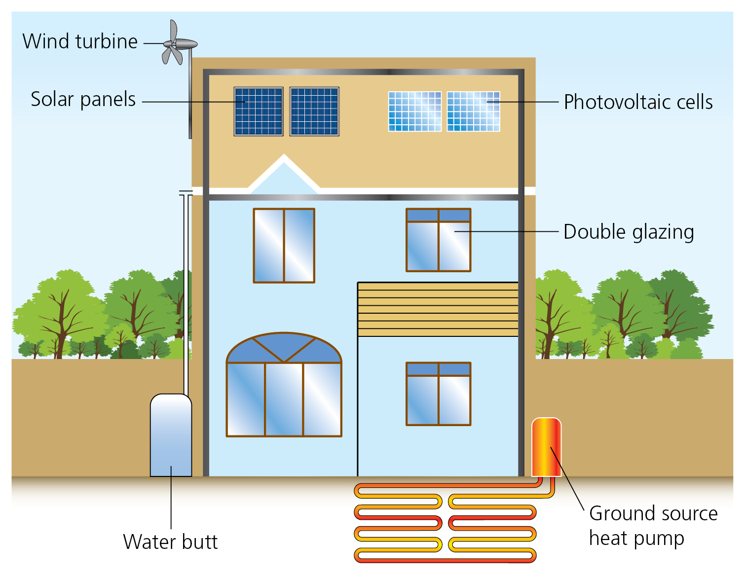
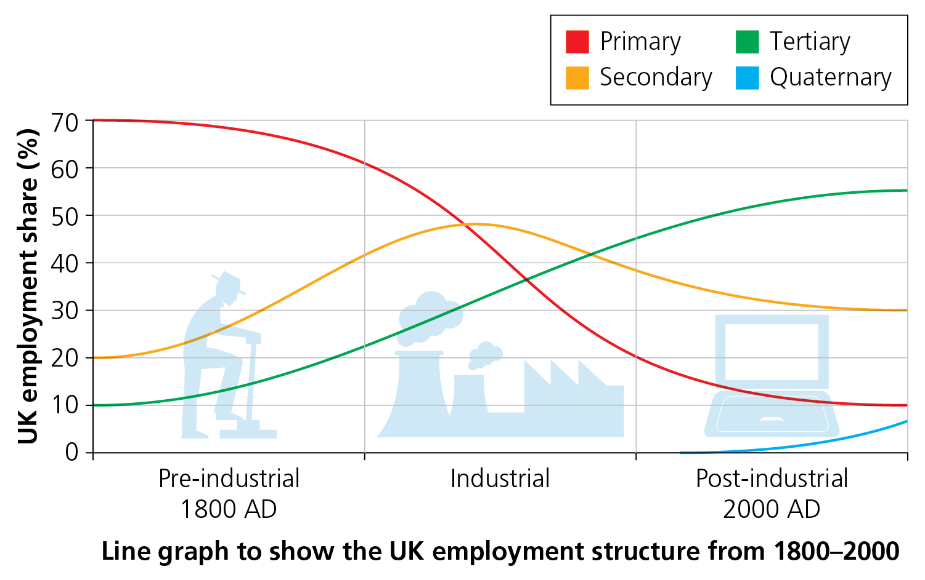

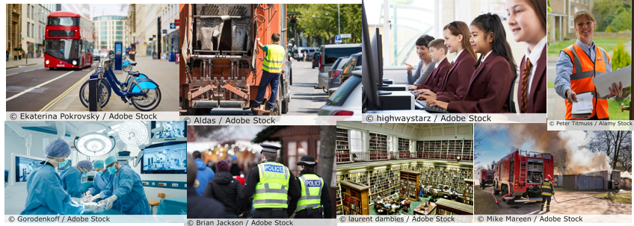
What are the public services and amenities like in your area? Write a list of them, and link them to significant landmarks. Say whether you have visited them yourself.
Explain how you could redesign your school to make it more fit for the future.
How like your house or school is this diagram of a house of the future?

5 words to remember
economic issues: things to consider in relation to how money is made, spent and allocated in spaces, for example Should money be spent on a new railway, road or bike lane?
environmental issues: things to consider relating to how humans and the natural world and spaces interact, for example There is a new housing development in an area where the protected newt lives; should the houses be built?
landmark: a significant human or physical feature that people know, name and recognise
social issues: things to consider relating to how people interact with each other and with nearby spaces, for example A local park needs to be shared by everyone in the community; a small group of users is spoiling it for everyone – what should be done?
sustainability: ensuring that whatever resources we use, and waste that we produce, is not too damaging for people and the planet’s future

