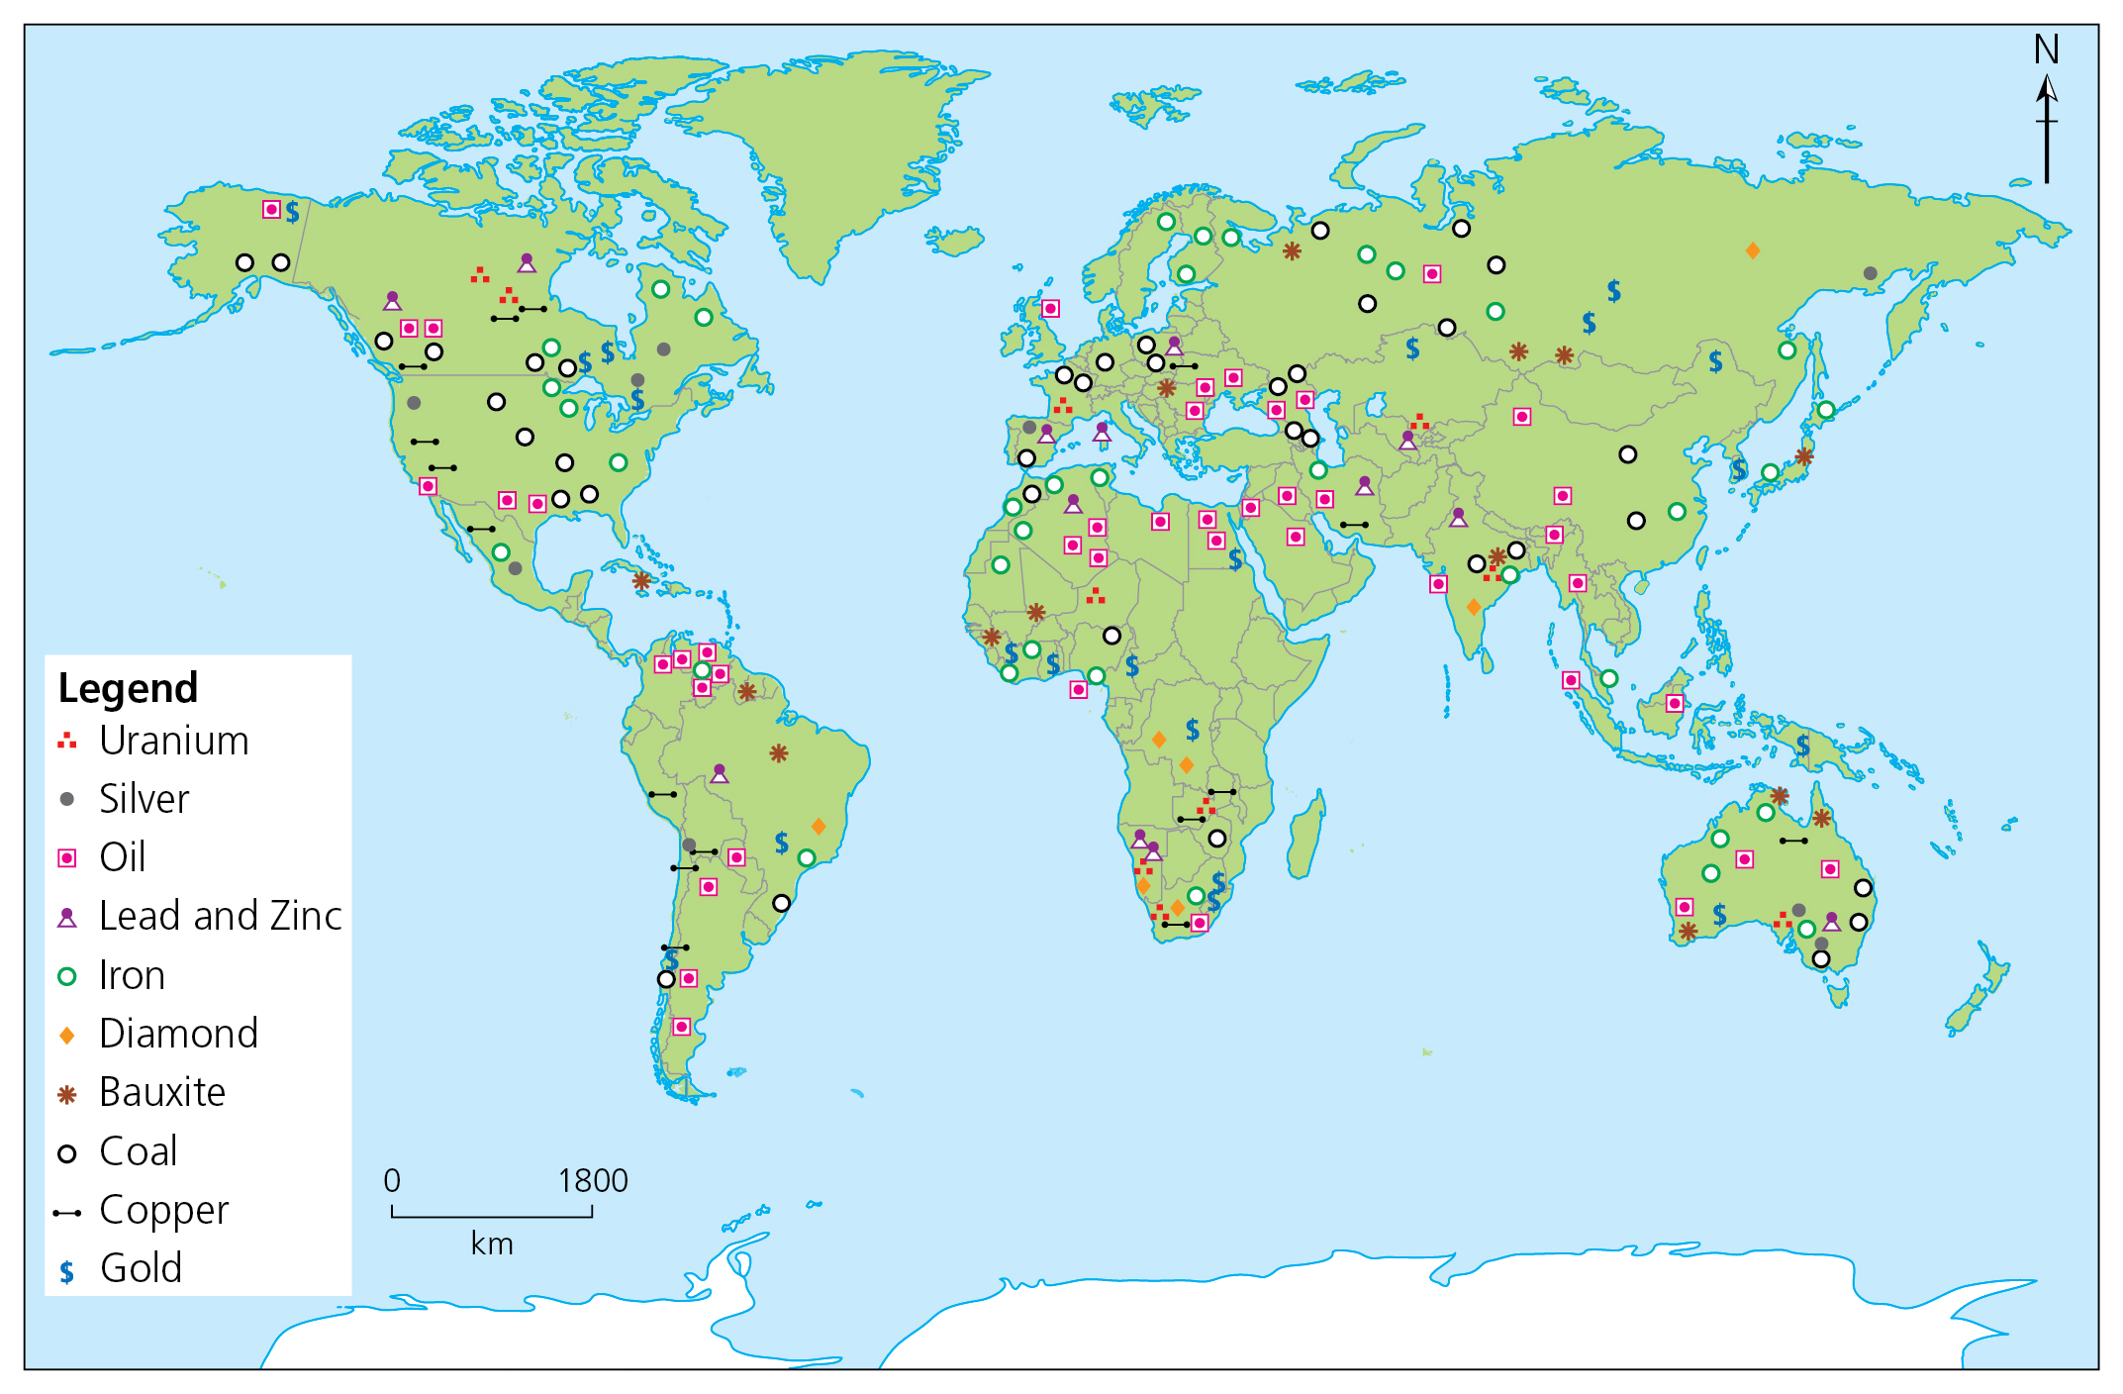
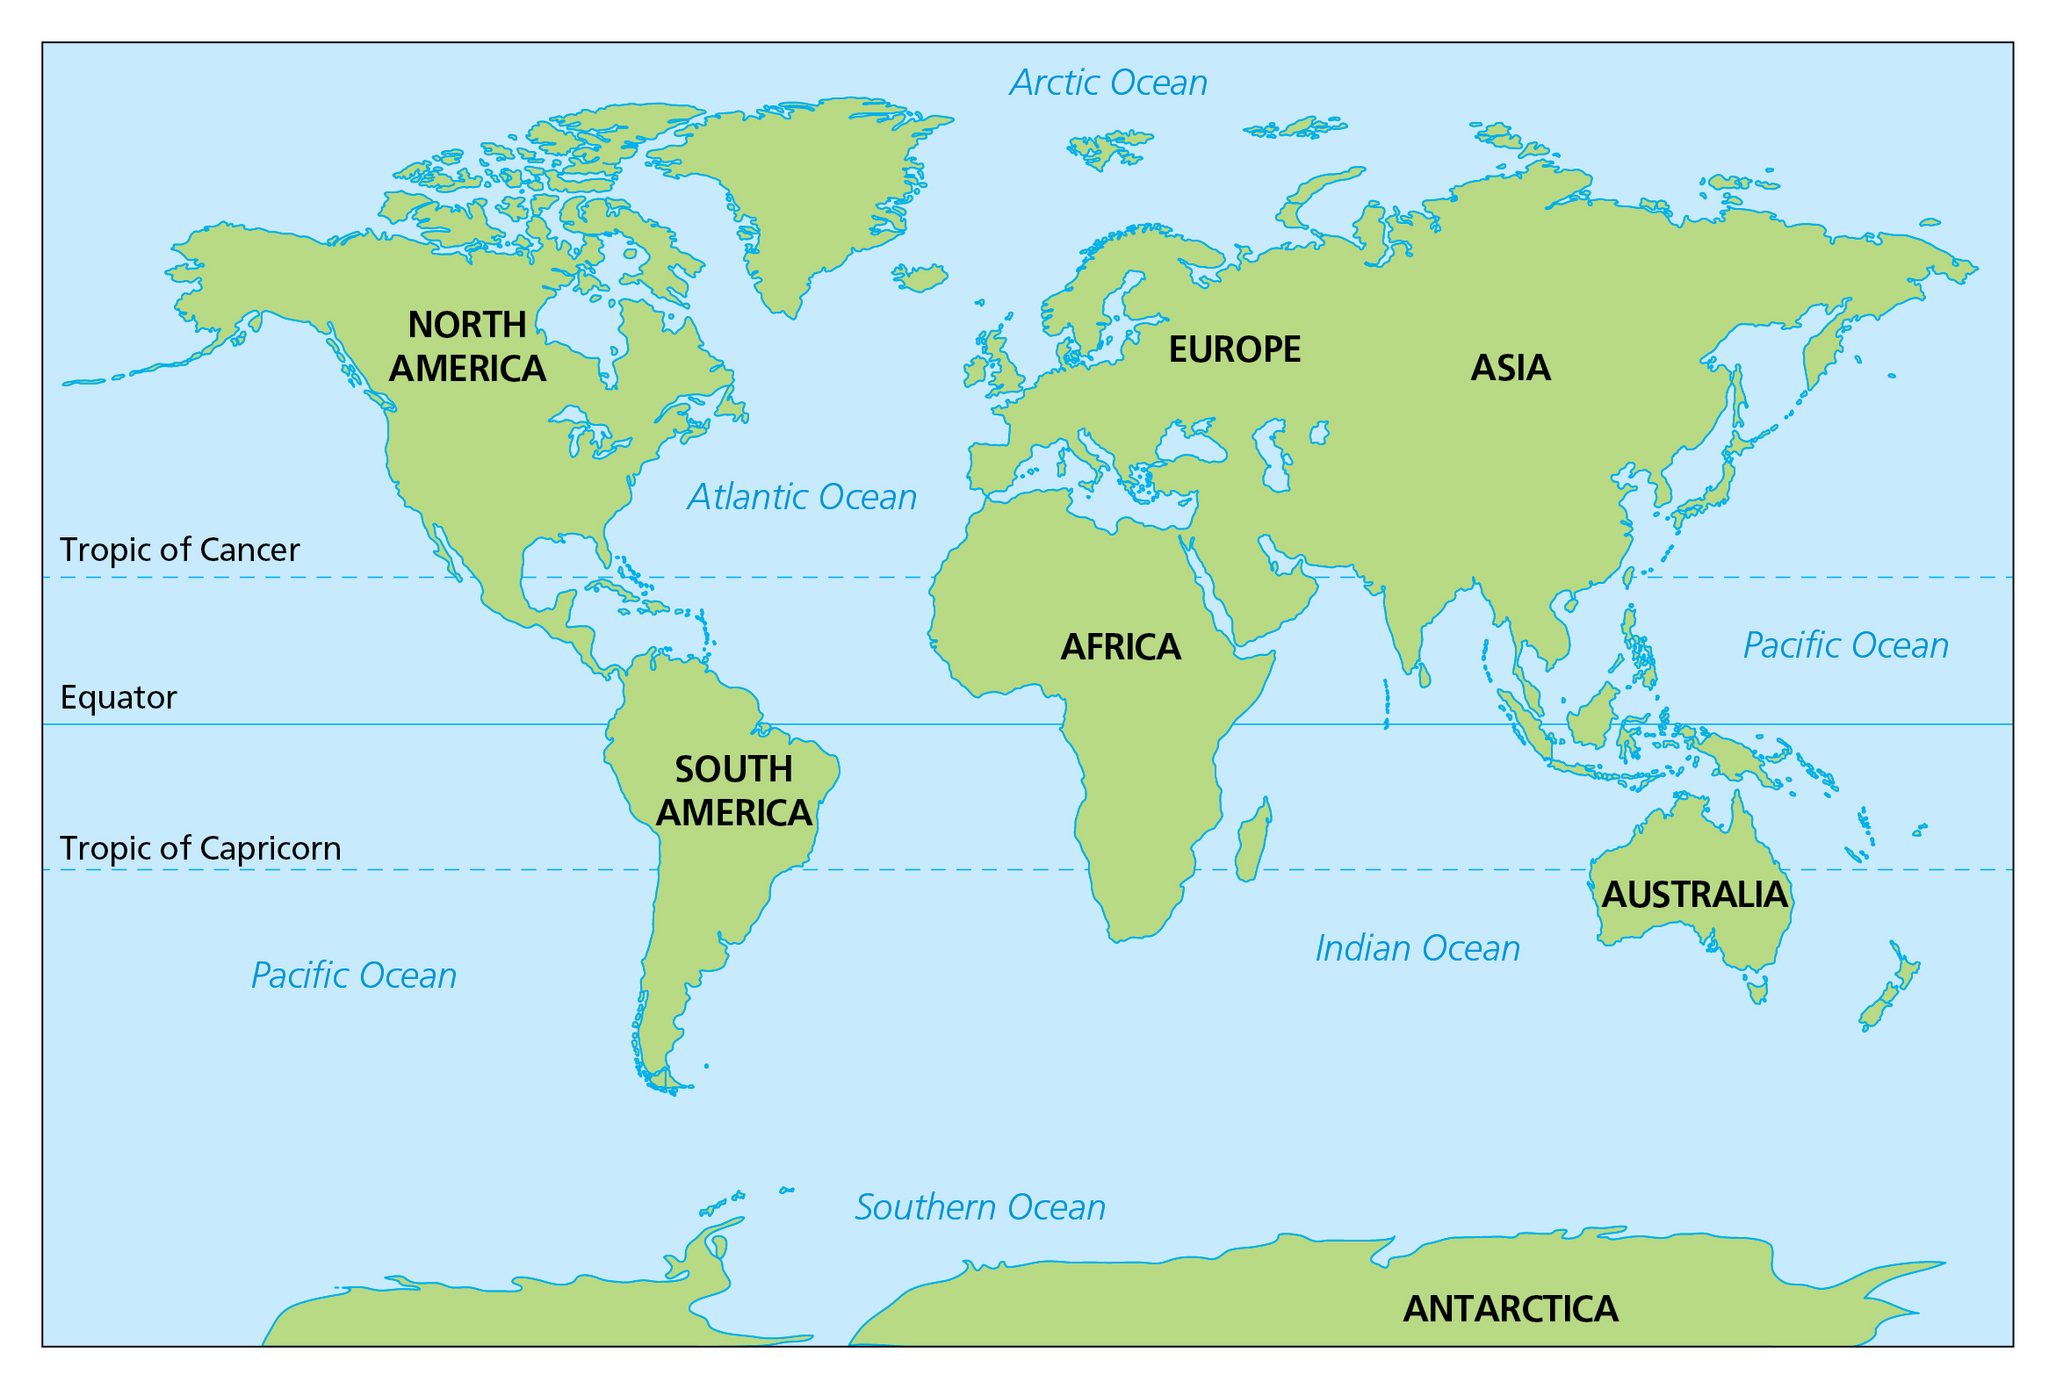

Key takeaways
- Scientists are providing increasing evidence of environmental change and stress. Around the world, glaciers and ice sheets are retreating, the overall health and diversity of wildlife is declining, human numbers are increasing and natural resources are over-exploited. Most people believe we need to take firm action to address these problems.
- The biggest threats to our oceans are: pollution; climate change; overfishing; extraction of oil and gas from the seabed; habitat destruction; and the introduction of alien species (from other ecosystems).
- Some issues are global in scale, while some are local. You may know of some local issues, which might be related to landscapes (river or water courses) or waste (where rubbish is found, stored and processed), or you may know of an issue around sound, light or air pollution.
- A Marine Protected Area is a space in the ocean where human activities are more strictly regulated than the surrounding waters. Positives of these are that they maintain biodiversity and provide refuges for endangered and commercial species. They protect critical habitats from damage by destructive fishing practices and other human activities, and allow them to recover. They provide areas where fish are able to reproduce, spawn and grow to their adult size. They also increase fish catches (both size and quantity) in surrounding fishing grounds, and they can build resilience to protect against damaging external impacts, such as climate change, and help to maintain local cultures, economies and livelihoods that are intricately linked to the marine environment.
- On the negative side, they can reduce fishing-related jobs and increase the cost of living. MPAs do not tackle other key issues that affect marine habitats, such as worsening pollution from the land and marine debris. Not all the benefits to fish populations are proven. Some of the benefits apply only to large MPAs. Scientists don’t all agree – some feel seasonal / spawning closures or daily / seasonal-take limits may be better management options, and that banning all fishing in particular areas is too extreme and not necessary. MPAs all have different rules – commercial fishing is allowed in some areas, which negates a lot of the advantages.

This map shows the minerals listed and where they can be found across the world. Other minerals include: seashells, diamonds, rubies, pyrite (fool’s gold), table salt, aluminium, steel, gravel, brick, sand and stone.

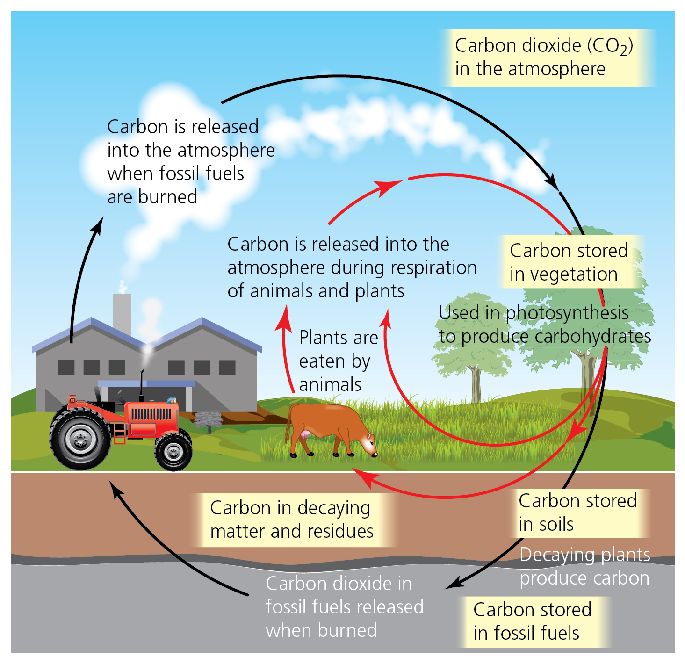
Do you remember all the continent and ocean names? Test yourself! Remember we use Oceania as well, and not Australia or Australasia.

Do you know what all these types of energy are? This is our energy mix.
- Gas: 38.5%
- Wind: 26.8%
- Nuclear: 15.5%
- Biomass: 5.2%
- Coal: 1.5%
- Solar: 4.4%
- Imports (mixed source): 5.5%
- Hydro: 1.8%
- Energy storage: 0.9%
www.nationalgrideso.com/news/britains-electricity-explained-2022-review
Do you think you can explain the difference between wind power, biomass, wave energy, geothermal energy, hydroelectricity, tidal energy and solar energy? Have a go!
Write a description of the carbon cycle, under the headings: ‘Carbon use and release’ and ‘Carbon storage and decay’. Use the diagram to the right to help.
5 words to remember
biodiversity: an area rich in life (human, plant and animal, but particularly non-human)
endangered: wildlife that is at risk due to habitat destruction, or being harmed or hunted
environmental issues: things to consider relating to how humans and the natural world and spaces interact, for example There is a new housing development in an area where the protected newt lives; should the houses be built?
habitat destruction: losing specific areas that support human and animal life
river: a natural watercourse, flowing towards a sea, ocean or lake

