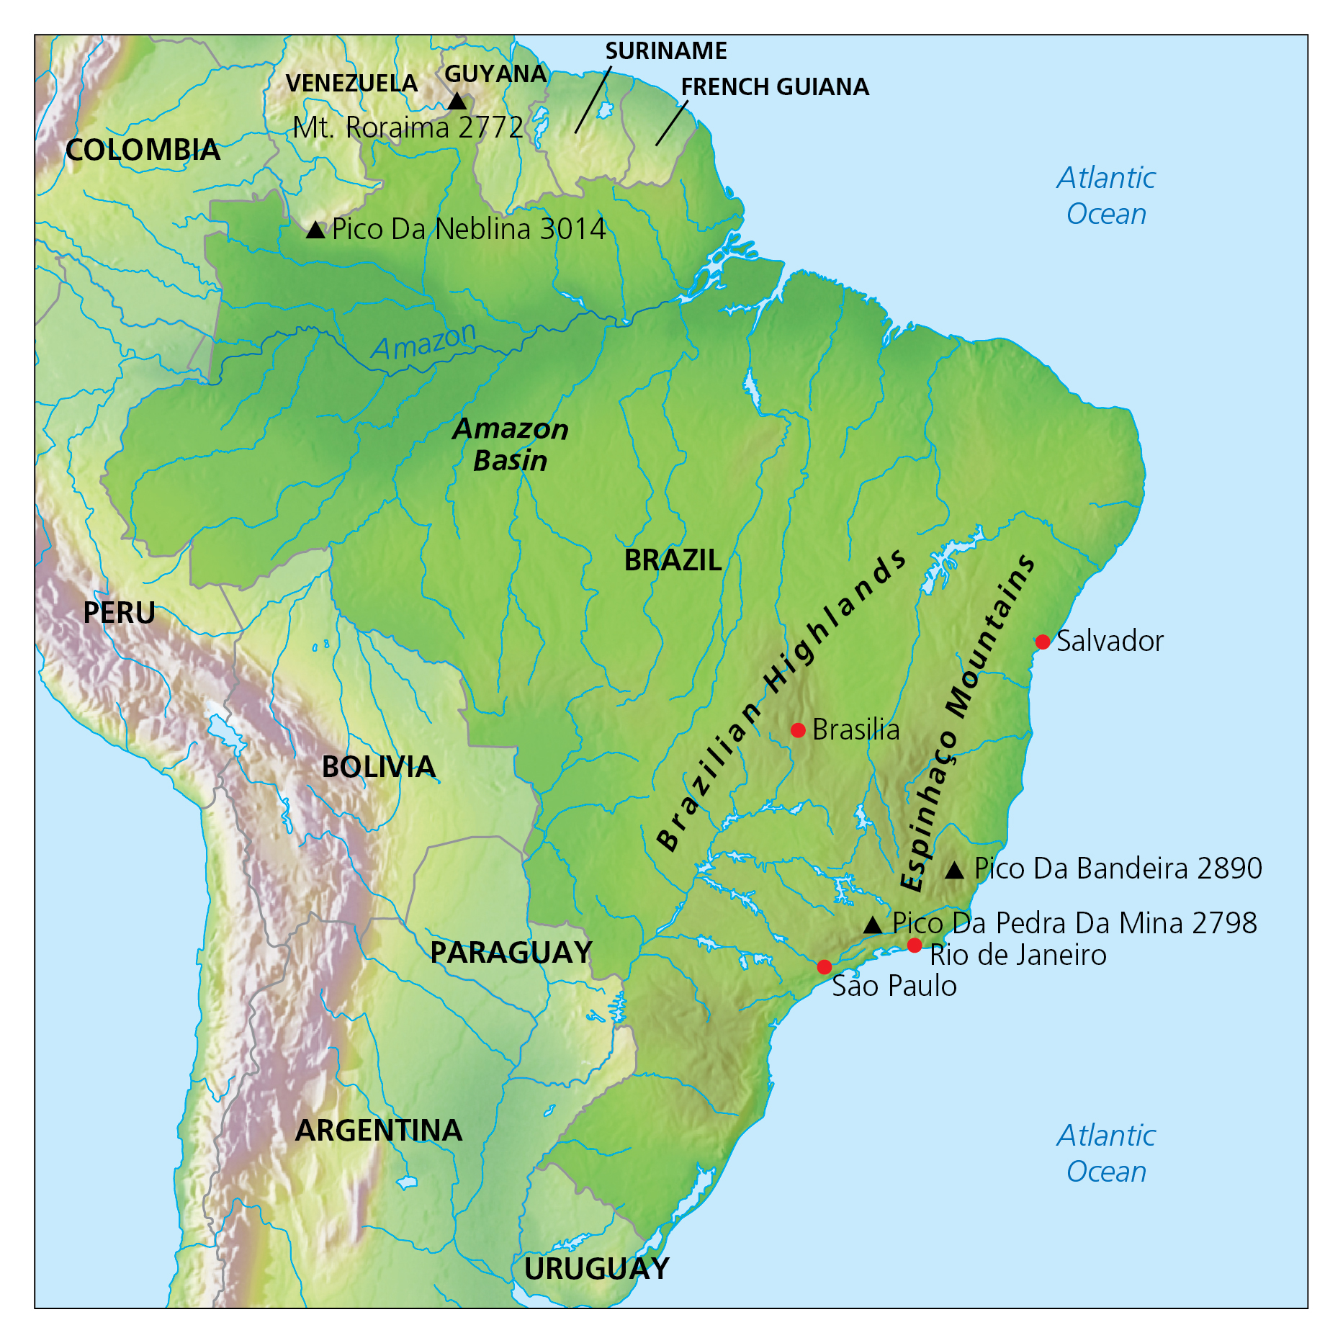
Key takeaways
- The Amazon is a vast region that spans nine countries: Brazil, Bolivia, Peru, Ecuador, Colombia, Venezuela, Guyana and Suriname, as well as French Guiana (an overseas territory of France).
- The Amazon River basin is home to the largest rainforest in the world, and it covers almost 40% of South America.
- The region consists of a variety of ecosystems, including rainforests, seasonal forests, deciduous forests, flooded forests and savannahs. However, the region is most renowned for its rainforest, which covers most of the Amazon River basin. The rainforest covers 5.5 million square kilometres of the basin, 60% of which is in Brazil.
- The Amazon represents over half the planet’s remaining rainforests and has an estimated 390 billion individual trees, comprised of 16,000 species.
- The Amazon is home to an estimated 10% of all species found on Earth. Scientists estimate that there are at least 40,000 plant species, 427 types of mammal, 1300 types of bird, 378 types of reptile, 400 types of amphibian and around 3000 types of freshwater fish.
- The Amazon is also home to more than 30 million people, and about 9% of them are indigenous people from 350 different ethnic groups, more than 60 of which still remain largely isolated.
- The Amazon River is the largest river by discharge of water in the world – greater than the next seven largest rivers combined. It is the second longest river in the world after the Nile, and has the largest drainage basin in the world – about 7,050,000 square kilometres – which accounts for approximately one-fifth of the world’s total river flow.
- The Meeting of Waters is the confluence between the Rio Negro, a river with dark water, and the sandy-coloured Rio Solimões, which run side by side without mixing for 6 kilometres. The reason for the phenomenon is differences in temperature, speed and water density of the two rivers.

The Amazon has a tropical climate, which is typical in areas close to the equator (12° north or south of the equator). There are only two seasons: wet and dry. The region is undergoing change due to commercial development, particularly mining (for iron ore and gold), hydroelectric schemes, road building (the Trans-Amazon highway), logging and forest-clearance fires.

The Amazon region is globally significant, both ecologically and environmentally, but it is also an important comparison to many areas of the UK that are special and threatened. There are currently 1150 species and 65 habitats on the UK Biodiversity Action Plan, which is a published list of conservation priorities that are under threat because of their rarity and rate of decline.

Remember: weather refers to the conditions on a particular day, while climate is the average weather pattern of a place.

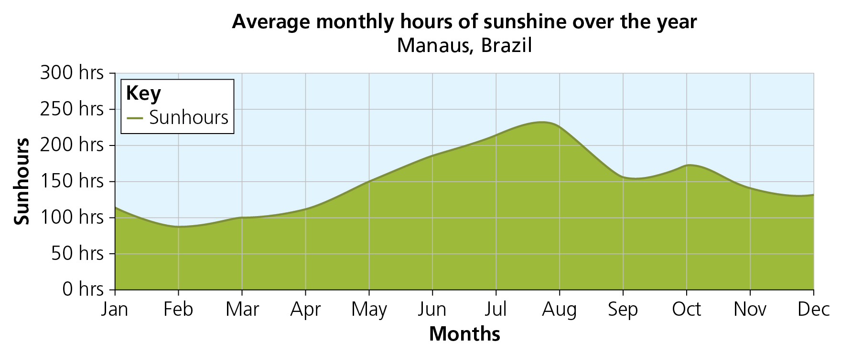
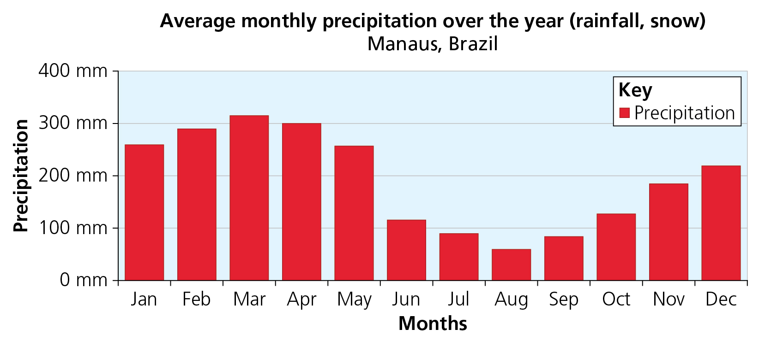
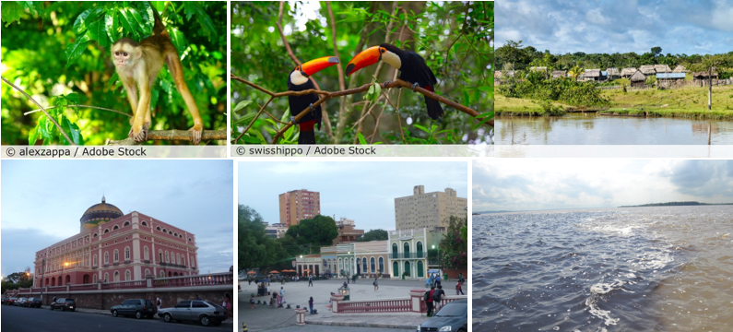
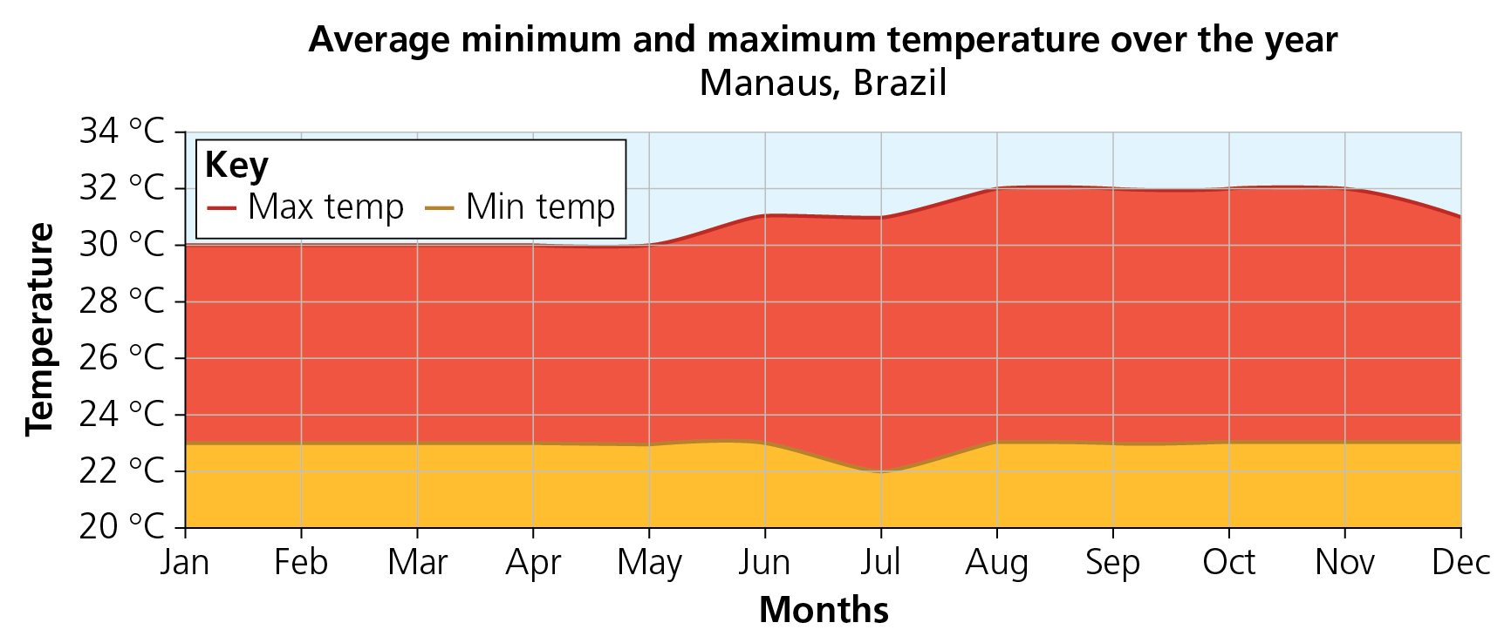
Look at the three graphs and the photos of Brazil. The graphs show temperature, hours of sunshine and monthly rainfall. Write a 12-month diary of what you see through your window from your home in Manaus, and the weather you might encounter.
5 words to remember
Amazon River: the river that runs through the basin; rio is the Portuguese name for ‘river’
Amazon River basin: a vast region that spans nine countries, covering 40% of South America
conservation: people protecting areas so that landscapes and wildlife can thrive, rather than just survive
Portuguese: the language spoken in Brazil; people speak this language there because of settlers from Europe hundreds of years ago
river: a natural watercourse, flowing towards a sea, ocean or lake

