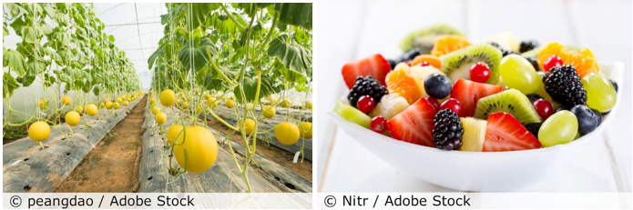

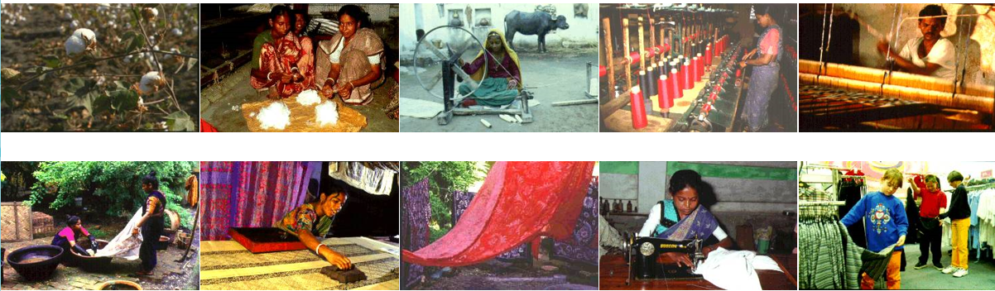

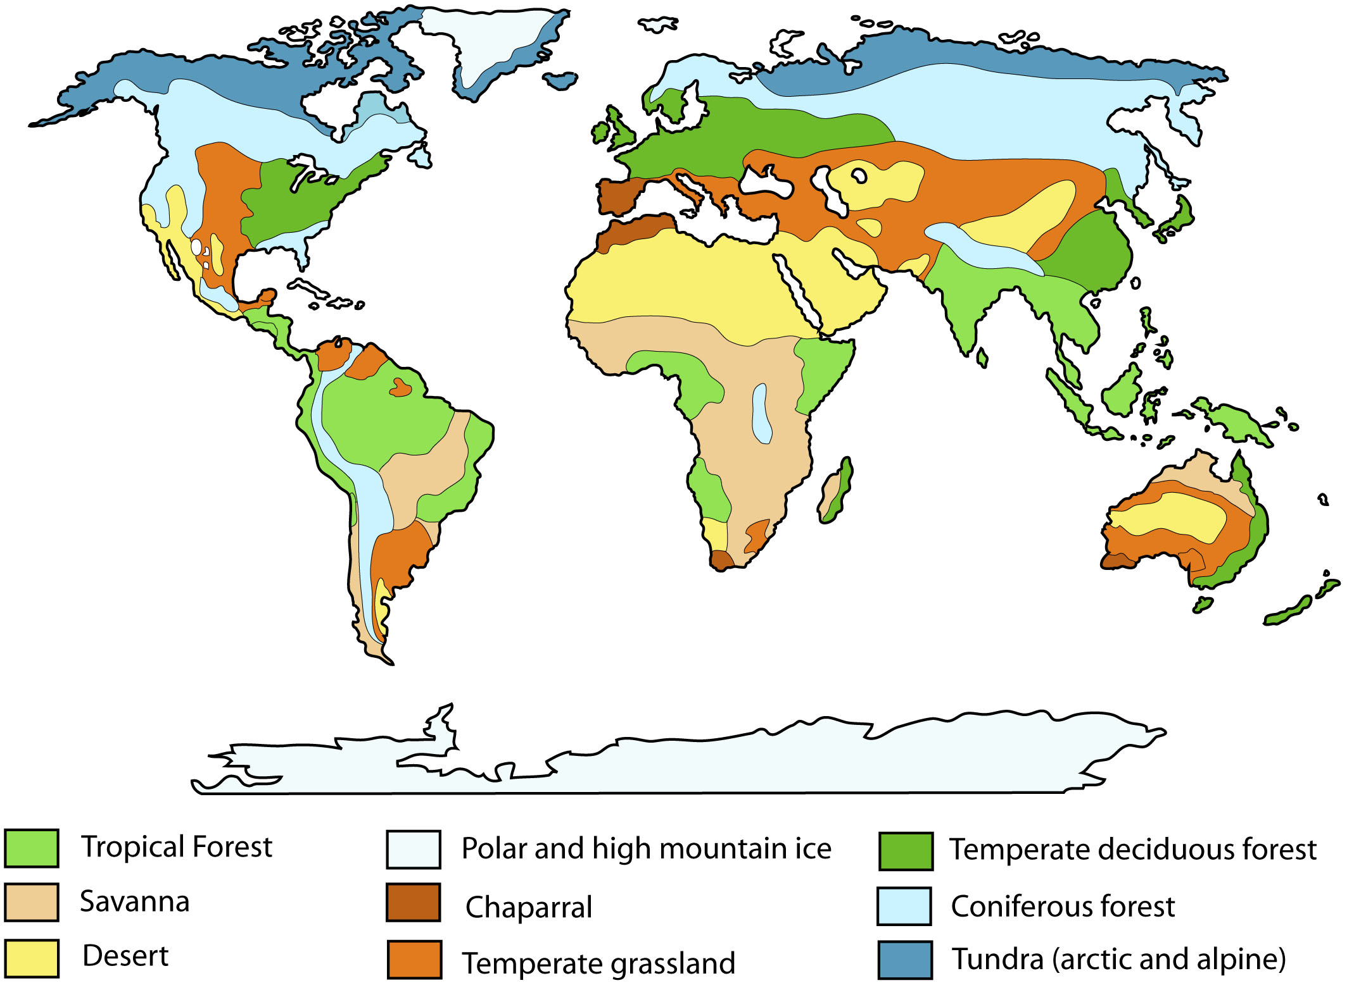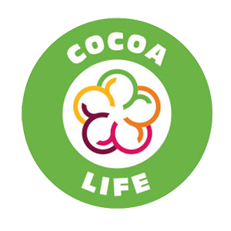
The top six countries that export clothing and textiles to the UK changes from time to time; in 2019–2020, they were: China, Bangladesh, Turkey, Netherlands, India and Italy.

Around half the food consumed in the UK originates in the UK, and half is from overseas. This is stable over time. About 40% of food and drink comes from four countries: the Netherlands, Republic of Ireland, Germany and France. About a third (30%) comes from the EU, 4% from Africa, 4% from Asia, 4% from North America, 4% from South America, 2% from the rest of Europe and 1% from Oceania. The UK produces over 50% of its vegetables, but only 16% of fruit.
Key takeaways
- The UK buys and sells goods from all over the world. We buy (import) more than we sell (export). Reasons for this include that we are a small country and have a high population for our size. We also have a limited amount of land on which to grow food, particularly of the types we choose to eat.
- The UK imports goods from all over the world, and the top products are: cars, medicines, gas, metals, oil, clothes and computers / electrical equipment. The top five countries they come from are: Germany, China, Netherlands, USA and France.
- Fruit often comes from biomes different from our own. The world’s major biomes include: tropical forest, savannah, desert, Chaparral, temperate grassland, temperate deciduous forest, coniferous forest, tundra, and polar and high mountain ice.
- Fairtrade aims to ensure a fair deal for food producers. This includes creating opportunities for food producers in developing countries, and ensuring trading practices are fair in terms of payment and prices, that no children are being exploited and that working conditions are safe. Fairtrade items include coffee, cocoa, wine, sugar, fruit (such as bananas), fruit juice, flowers and even gold.
- There are other schemes that try to balance the protection of land and the people who grow the products. They include the Rainforest Alliance, the Marine Stewardship Council, Cocoa Life and Cocoa Plan. Protected-origin schemes protect the names of specific products that promote their unique characteristics, and link them to their geographical origin, as well as their traditional know-how.
- There are many issues surrounding imported versus locally sourced food. Some of the pros of imported food include: we have access to a wider variety of food, it is generally cheaper, jobs are created in other locations and we have more land available for other uses.
- Pros of eating locally produced food include that imported perishable food is transported by plane, so eating locally reduces fossil fuels and pollution; imported perishable food is often modified so it doesn’t spoil in transit; more jobs are created for local farmers; locally sourced food usually has less packaging; and local and seasonal food has a higher nutrition density.

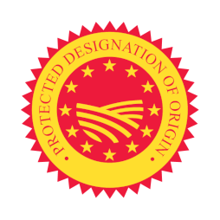
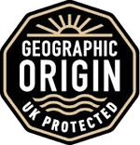
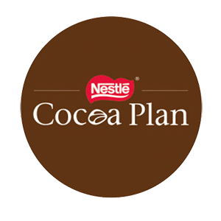
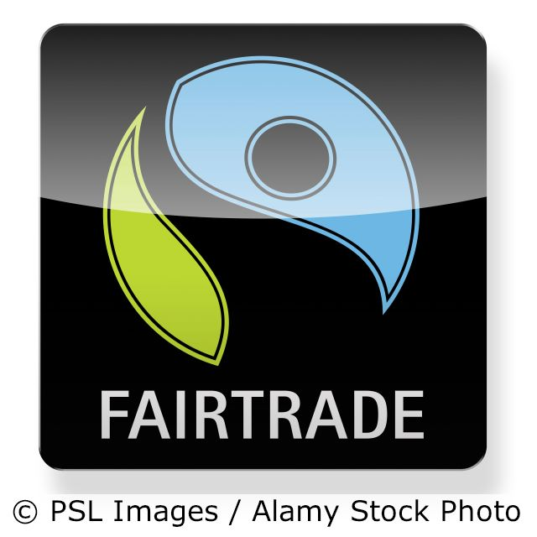
A map of world biomes, where some of the foods discussed might grow
Where products come from is complicated. Take a chocolate bar as an example. It may have been manufactured in a factory here in the UK, but its ingredients may be imported from many countries: salt from China; calcium sulphate from India; palm oil from south-east Asia; whey from New Zealand; milk and wheat from the EU; sugar from the Caribbean; and cocoa from South America.
What can you find out about the different eco labels that exist? What do they do? Look at the makers of some of your favourite chocolates on the Cocoa Life and Cocoa Plan websites.
Protected origin: EU
Protected origin: UK
Write four things that are good about locally sourced food and four things that are negative. Think about how buying some things from overseas can be useful too.
5 words to remember
biomes: including deserts, forests, grasslands, tundra and aquatic environments, biomes are defined by the climate, soil, organisms, flora and fauna of a large area; each biome consists of many ecosystems whose communities have adapted to the small differences in climate and the environment inside the biome
export: what we sell to somewhere else
fossil fuels: natural fuels (oil, gas, coal) found in the ground, which add carbon dioxide to the atmosphere once burned and many people suggest we need to remove from use; they come from the remains of dead plants or animals
import: what we buy from somewhere else
protected origin: a label that says that a product has been made in, or made from ingredients from, a particular area (for example Melton Mowbray Pork Pies in the UK – see the top logo to the right – and Parmesan cheese, Champagne or Kalamata olive oil in the EU – see the bottom logo to the right); this helps buyers trust and distinguish quality products while also helping producers to market their products better and protect their jobs and businesses

