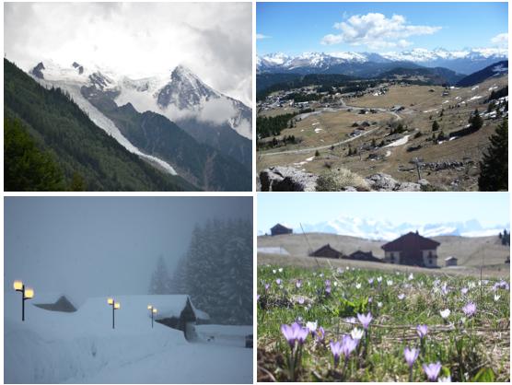

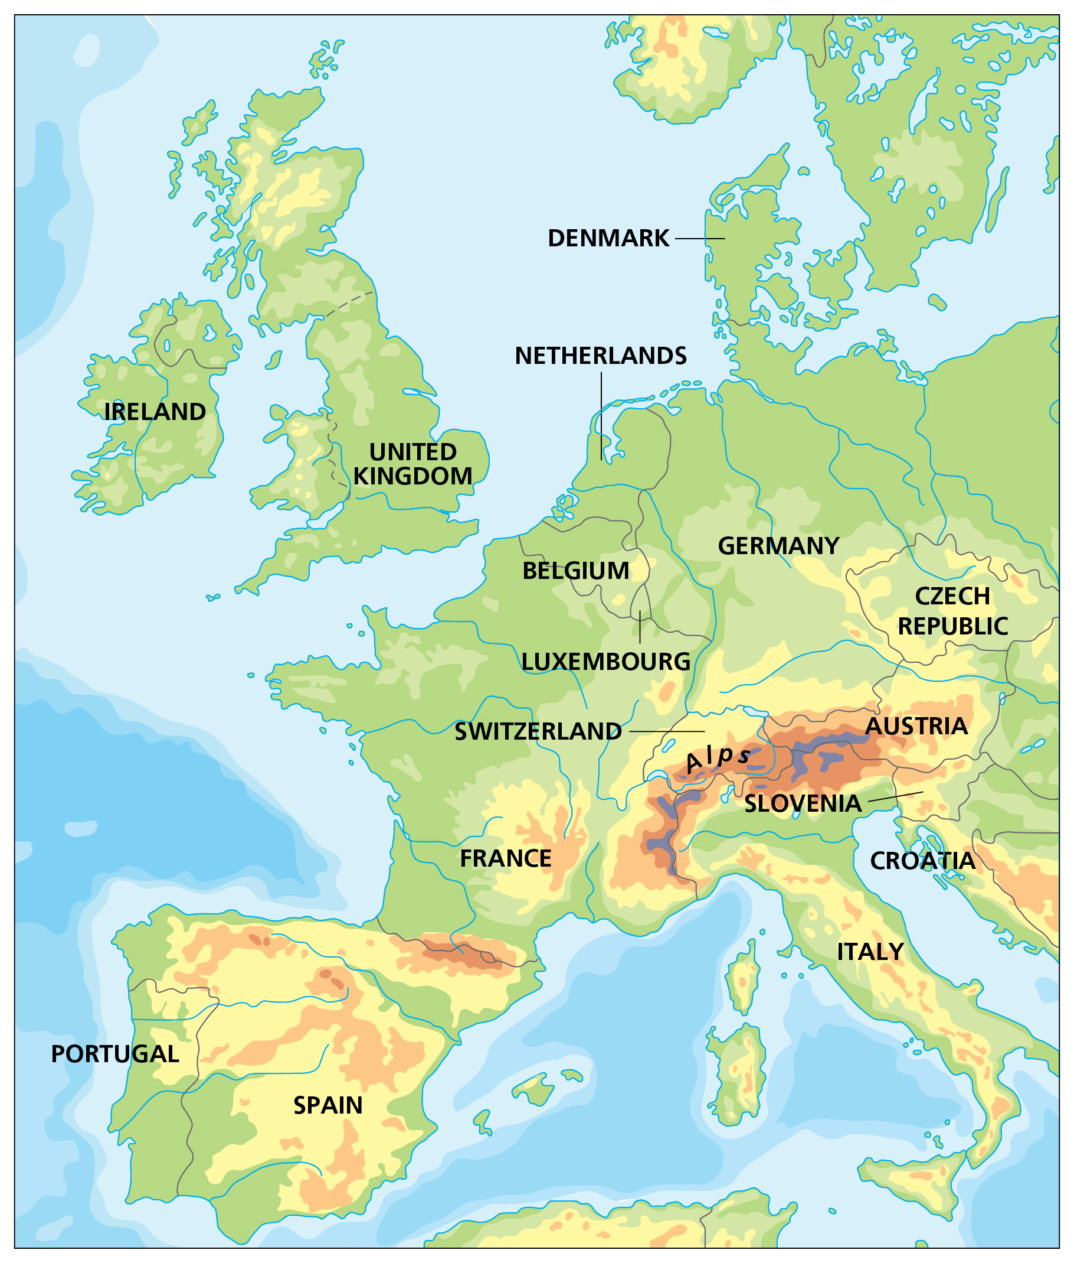

The Alps are one of the great European mountain ranges, and are spread across eight countries: France, Switzerland, Liechtenstein, Germany, Austria, Italy, Slovenia and Monaco.

Key takeaways
- There are mountains in all countries of the UK, particularly in Scotland and Wales. The tallest are Ben Nevis at 1345 metres and Yr Wyddfa (Snowdon) at 1065 metres. The UK has a temperate climate, so we have a range of landscapes. Snow falls across the UK, but particularly on high ground. Most snow melts by the summer. We have four clear seasons, with weather coming from the south in summer, and north and east in winter, which brings the colder and wetter weather from across the Atlantic. As we know though, this wet weather can come at almost any time in the UK.
- The Alps also have a temperate climate at lower altitudes. The effect of this is prevailing winds carrying warm air belonging to the lower region into an upper zone, where it expands and loses heat, and there is often precipitation in the form of snow or rain. In the Alps, the temperature can drop to –10°C (14°F) in winter and rise to 30°C (86°F) in summer.
- Homes must protect and insulate their inhabitants from extreme cold and heavy snowfall in winter; the rest of the year there are high levels of rain. The most typical approach includes a stone-built ground floor, often partly recessed into the mountainside to offer some protection from the wind. The presence of cows stabled here creates some extra warmth for the human accommodation above. This ground floor provides a solid foundation for the more visible timber upper floors, supported by a framework of massive joists.

Mont Blanc spans the border of France and Italy, and is the highest mountain in the Alps at 4810 metres. The Alps were formed over tens of millions of years as the African and Eurasian tectonic plates collided. Extreme shortening caused by the event resulted in marine sedimentary rocks rising by thrusting and folding into high mountain peaks such as Mont Blanc and the Matterhorn.

Prevailing winds bring warm air from the temperate climate of lower areas to higher altitudes. The air is forced to rise, where it cools. This causes the water vapour in the air to condense to form clouds. The water vapour falls as rain or – if the temperature is below 0°C – as snow.

More than 120 million tourists visit the Alps each year – tourism provides essential income. Other chief industries include forestry, farming, cheese-making and baking, woodworking and carpentry.

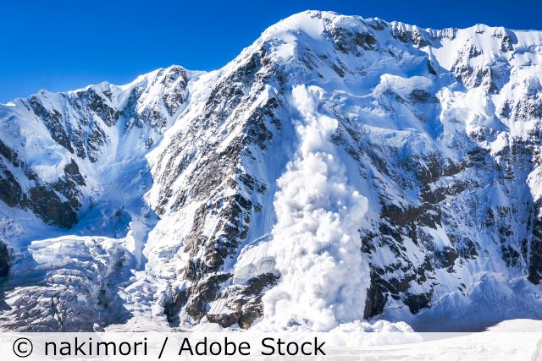
An avalanche occurs when a slab of snow, lying on top of a weaker layer of snow, fractures and slides down a steep slope. Many steps are taken in the Alps to reduce the risk of avalanches, including: observation and forecasting; active interventions such as triggering smaller, less hazardous avalanches or snow grooming (using large tracked vehicles); and permanent interventions such as snow retention structures (including snow racks, nets and snow bridges), reforestation and avalanche barriers.

5 words to remember
climate: the average weather pattern of a place over many years, in the long term; climates can be predominantly hot, cold, wet or dry; hot and wet; hot and dry; and so on – the climate of a place affects the soil, flora and fauna of that place, and impacts on human activity in a variety of ways
mountain: landform that rises high above the surrounding terrain in a limited area, made from rocks and earth; generally described as higher and steeper than a hill
region: an area that is defined by certain unifying characteristics, which may be physical, human or cultural
tourism: travelling for fun or holidays
wind: any horizontal movement of air, caused by pressure differences, which in turn are caused by temperature differences
Explain the steps humans take to protect themselves from avalanches. Then, explain the steps individuals can take to protect themselves.

