Key takeaways
- The British Isles is a geographical term and refers to the islands of Great Britain and Ireland (including the Republic of Ireland), as well as the approximately 5000 smaller islands around the coastline.
- The United Kingdom of Great Britain and Northern Ireland is a political union, consisting of England, Wales, Scotland and Northern Ireland. The Channel Islands and the Isle of Man are not part of the UK (they are Crown Dependencies). The UK withdrew from the European Union in January 2020, in a process called Brexit. The EU is a political and economic union of 27 member states that are located primarily in Europe.
- Great Britain is the official name given to the countries of England, Wales and Scotland. It is the largest island of the British Isles. The United Kingdom of Great Britain and Northern Ireland lies in Europe, located north west of the European mainland. It includes the island of Great Britain, the north-eastern part of the island of Ireland and other smaller islands.
- The UK is the world’s 22nd most-populated country, with some 67 million inhabitants. London, the capital city, covers the third-largest urban area in Europe.
- The UK has the sixth-largest national economy in the world. The service sector contributes around 79% of GDP (2023) and 83% of employment. Services are jobs where people do things for other people, and they might work in a city or town. Examples include working with money (banks, insurance); selling things (from shops, or from warehouses – known as wholesale); driving passengers (taxis, trains, buses); presenting on radio or TV; working for a council, the government or NHS; cutting hair; even being your teacher. Financial services (working with money or insurance) is important to the UK and based in London. London is the world’s largest financial centre, together with New York. Tourism is a vital industry, with the UK listed as the sixth top world tourist destination. The pharmaceutical and automotive industries are also major employers and exporters.
- There are significant regional variations in wealth: south-east England and southern Scotland are the richest areas.
- UK regions are usually listed as: Scotland, Wales, Northern Ireland, north-east England, north-west England, Yorkshire and the Humber, East Midlands, West Midlands, East of England, Greater London, south-east England and south-west England. A region is a politically defined area and sometimes changes.
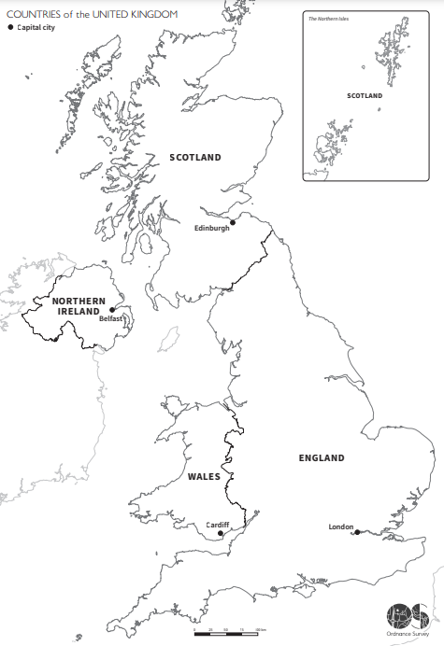

Make sure you know the location of where you live.

You also should know the latitude and longitude:
- London: 51°N and 0°W
- Manchester: 53.5°N and 3°W
- Birmingham: 52.5°N and 2°W
- Cardiff: 51.5°N and 3°W
- Belfast: 55°N and 6°W
- Edinburgh: 56°N and 3°W
- Cardiff: 51°N and 0°W

Explain what latitude and longitude mean. Write the cities above in a list from furthest north to south and east to west. Locate them on the map.

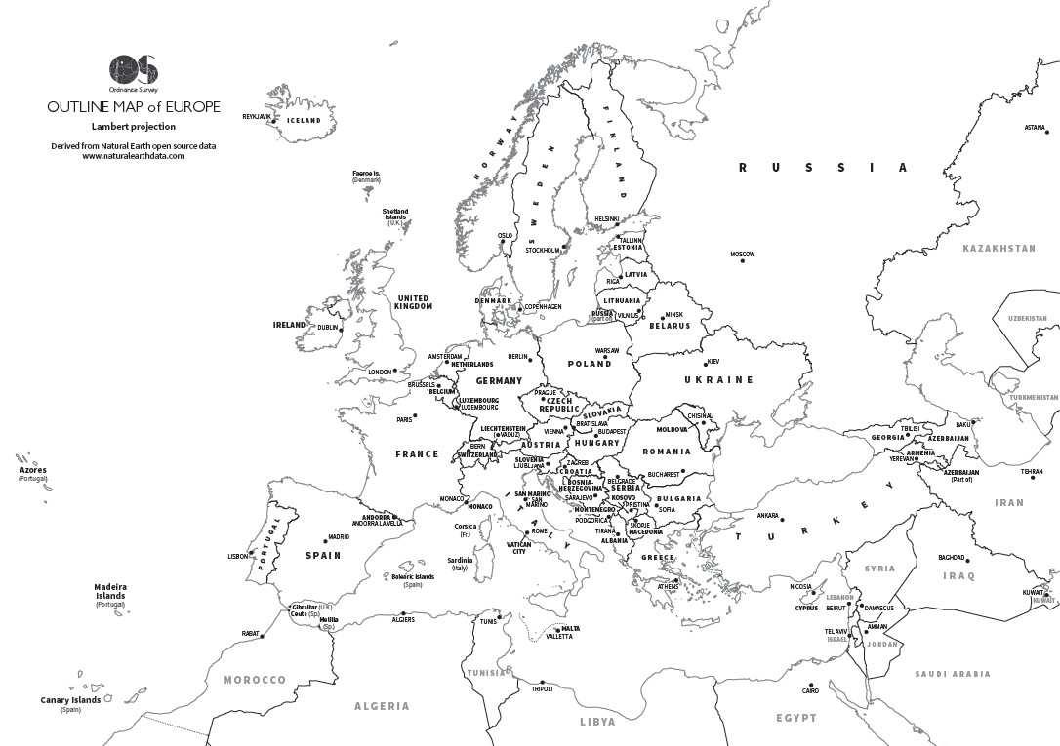
Landmarks in an area are important. They can be human or physical. A place of worship is a human landmark; a hill or river is a physical one. What do you have near you? Which landmarks in the list below can you find on a UK map?
Compare the populations of some of the UK’s cities:

- London: 9 million
- Birmingham: 1.1 million
- Manchester: 553,000
- Edinburgh: 526,000
- Belfast: 345,000
- Cardiff: 362,000
- Leeds–Bradford: 1,916,000
- Glasgow: 1,270,000
- Southampton–Portsmouth: 932,000
- Liverpool: 940,000
- Newcastle: 726,000
- Nottingham: 694,000
- Sheffield: 640,000

Free attractions (2022): 1 Natural History Museum 2 Brighton Pier 3 British Museum 4 Tate Modern 5 National Gallery 6 Victoria and Albert Museum 7 Somerset House 8 Science Museum 9 Abbey Gardens (Bury St Edmunds) 10 British Library
Paid-for attractions (2022): 1 Tower of London 2 Royal Botanic Gardens, Kew 3 RHS Garden Wisley 4 Windermere Lake Cruises 5 St Paul's Cathedral 6 Westminster Abbey 7 ZSL London Zoo 8 Adventure Island, Southend 9 Stonehenge 10 Colchester Zoo

5 words to remember
capital city: the largest or most significant settlement where people live and work; where major government buildings and offices and cultural sites, such as museums, are located; and where people visit to see landmarks
landmark: a significant human or physical feature that people know, name and recognise
region: an area that is defined by certain unifying characteristics, which may be physical, human or cultural
tourism: travelling for fun or holidays
United Kingdom: country consisting of Great Britain (England, Wales and Scotland) and Northern Ireland
Where have you, your family and friends been on holiday in Europe?
Why do you think they have mainly visited there?
How has your local area changed in the time you have been alive? How has it changed in the lifetime of your family?

……………………………………………………………………
………………………………………………………………………………………………………………………………………………………………………………………………………………………………………………………………………

