The rigid outermost shell of the Earth (called the crust) is broken up into seven or eight major interlocking tectonic plates, and numerous smaller plates. It’s like an egg with a cracked shell. With the cracked shell representing the thin crust, the white represents the hot magma of the semi-molten mantle, and the yolk represents the extremely hot core. The tectonic plates move (a few centimetres a year) towards, away from or sliding past each other. This results in volcanoes and earthquakes at their boundaries – the cracks in the egg’s shell.
Key takeaways
- Hot lava and gas are erupted by volcanoes on land and in the sea. A volcanic eruption covers the ground or seabed in ash and lava. Most volcanic eruptions and earthquakes occur around the Pacific Ocean. This is called the Pacific Ring of Fire.
- Pompeii, an ancient city in Italy, was buried by an eruption of the volcano Mount Vesuvius. Cotopaxi is a volcano in the Andes Mountains in Ecuador.
- Earthquakes occur all the time, including in the UK. Cracks and movement of the ground and lots of damage are caused by earthquakes. Lots of earthquakes occur in the USA along the coast of California when the San Andreas Fault moves.
- When tectonic plates move against each other, heat is generated – see the images to the right. This can heat and mobilise material in the Earth. Along with other molten material at depth, this can move upwards and come out through cracks in the Earth’s surface as lava. The volcanic eruptions can be fairly gentle, with lava running downhill and over the surface; can throw much volcanic ash into the air; or can be explosive. In very explosive eruptions, great boulders of rock can be thrown high into the sky.
- Volcanic eruptions under the sea, such as along the Mid-Atlantic Ridge, mean that the eastern and western sides of the Atlantic are moving apart along this ridge (at about 2.5 centimetres a year) and lava comes up and fills the gap.
- Converging plates (plates moving towards each other) are associated with mountain building and / or volcanoes, such as the Himalayas (where India meets Asia), the Andes (where there are active volcanoes, such as Cotopaxi) and the Ring of Fire. Subduction is when one plate is forced underneath another where they meet. At depth, the rocks in the sunken plate melt and lava is forced up through fractures, to erupt as volcanoes.
- An example of diverging plates is the Mid-Atlantic Ridge, where the Eurasian plate and the North American plate are moving apart, at about 2.5 centimetres a year. Magma from the Earth’s mantle rises to create new crust in the gap. Iceland sits on this ridge and is very actively volcanic.
- The San Andreas Fault in San Francisco, USA, is an example of plates sliding past each other. Tension increases along faults in the Earth’s crust as the plates grind together, which sudden movement – an earthquake – relieves.
- The Ring of Fire has all three types of plate boundary. It is the world’s most active earthquake and volcanic zone.

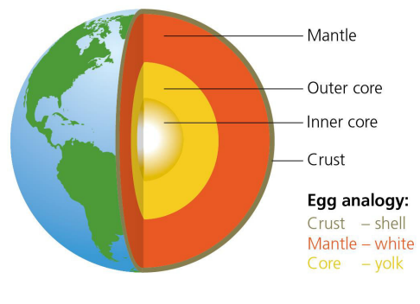
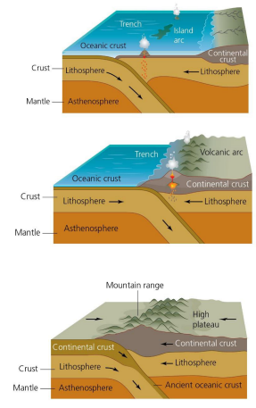

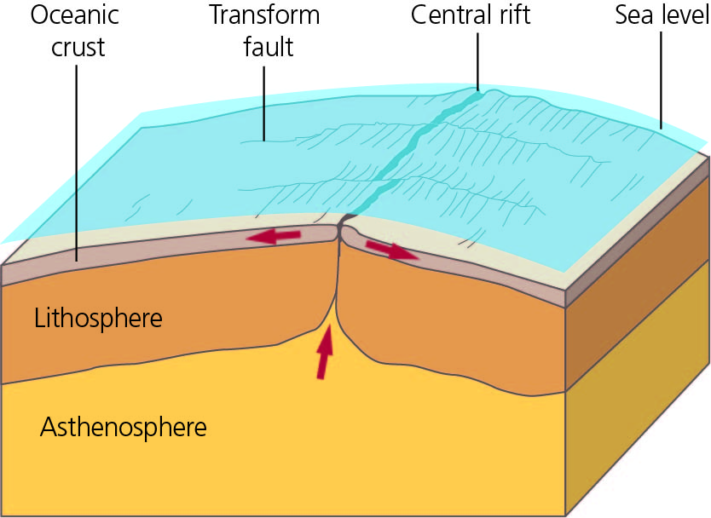

The middle three diagrams show convergent boundaries:
a) When ocean plates move towards each other (converge), an arc of islands with volcanoes is formed. The Philippines, Java and Sumatra are examples, but there are lots of others around the Pacific Ocean.
b) When an ocean and a land (continental) plate move towards each other, mountains with volcanoes are formed. The Andes in South America are an example.
c) When two land (continental) plates move towards each other, mountains are formed. The Himalayan Mountains are an example.

Did you know? The Richter scale to measure earthquake magnitude is logarithmic, which means that each one-point increase on the scale represents a tenfold increase in the power of the earthquake.

5 words to remember
core: centre of the Earth; the extremely hot inner core is solid and the outer core is molten
crust: outer layer of the Earth, which may be continental or oceanic, and consists of solid rock broken into tectonic plates
mantle: the layer of the Earth beneath the surface, which is semi-molten and very hot
molten: melted
USA: the third-largest country in the world by land area

This diagram at the bottom shows divergent plate boundaries – where new crust is generated as the plates pull away from each other. Convergent boundaries are where crust is destroyed as one plate dives under another, and transform boundaries are where crust is neither produced nor destroyed as the plates slide horizontally past each other.

The final type of plate boundary is a transform boundary. This is where crust is neither produced nor destroyed as the plates slide horizontally past each other.
Make sure you can define all three types of plate boundary: divergent, convergent and transform. Write a simple definition of each.

