The diagram below is a very unrealistic scene and is unlike most locations on Earth. Think about where you live. How different is it from this image? What other ways are there to stop water infiltrating the ground or reaching the rivers or sea? One example is the roof of your home, as it is made of tiles and the water can’t soak in. What else is there in the urban water cycle?
Key takeaways
- Water flows downhill so, wherever rainfall lands, the water moves downhill. Downhill is not always obvious, and sometimes in urban areas things get in the way.
- Water infiltrates and percolates. From a source, a stream develops, flows downhill, joins together with other streams and these eventually join to form a river. While flowing downhill, it creates landscape features by flooding, eroding, moving and depositing materials. The force of energy depends on the flow, which in turn is related to rainfall, drainage patterns, the gradient and the cross-section of the river channel.
- Humans use rivers for transport routes, water supply, water power, hydroelectric power, irrigation, religious beliefs, tourism (river cruises), sport (waterskiing) and leisure (hiking alongside). They endeavour to control rivers, diverting the course or enclosing it in open or closed channels as the rivers flow through urban areas and in areas that are susceptible to flooding.
- Streams are tributaries, and where they join is called a confluence. As the water flows downhill, it erodes a channel or valley and carries eroded material downstream.
- As the flow slows down on flatter land, the river cannot transport the eroded material (due to insufficient energy) so it deposits it. The river course may wind in meanders. Where a river joins the sea, possibly in an estuary, the water is brackish with the saltiness affected by the incoming and outgoing sea tides.
- Major world mountains include the Alps; Andes; Antarctic Mountains; Atlas; Drakensburg; Himalayas; Huangshan; North-West Highlands; Pyrenees; Rockies; and Snowdonia.

Write a definition of each of the following words:
- precipitation
- condensation
- transportation
- transpiration
- evaporation
- collection
- groundwater

Examples of definitions:
- infiltration: movement of water into soil
- percolation: the downward movement of water through soil
- surface runoff: when water hits the ground and moves depending on where it lands, for example it will soak into soil but run off concrete
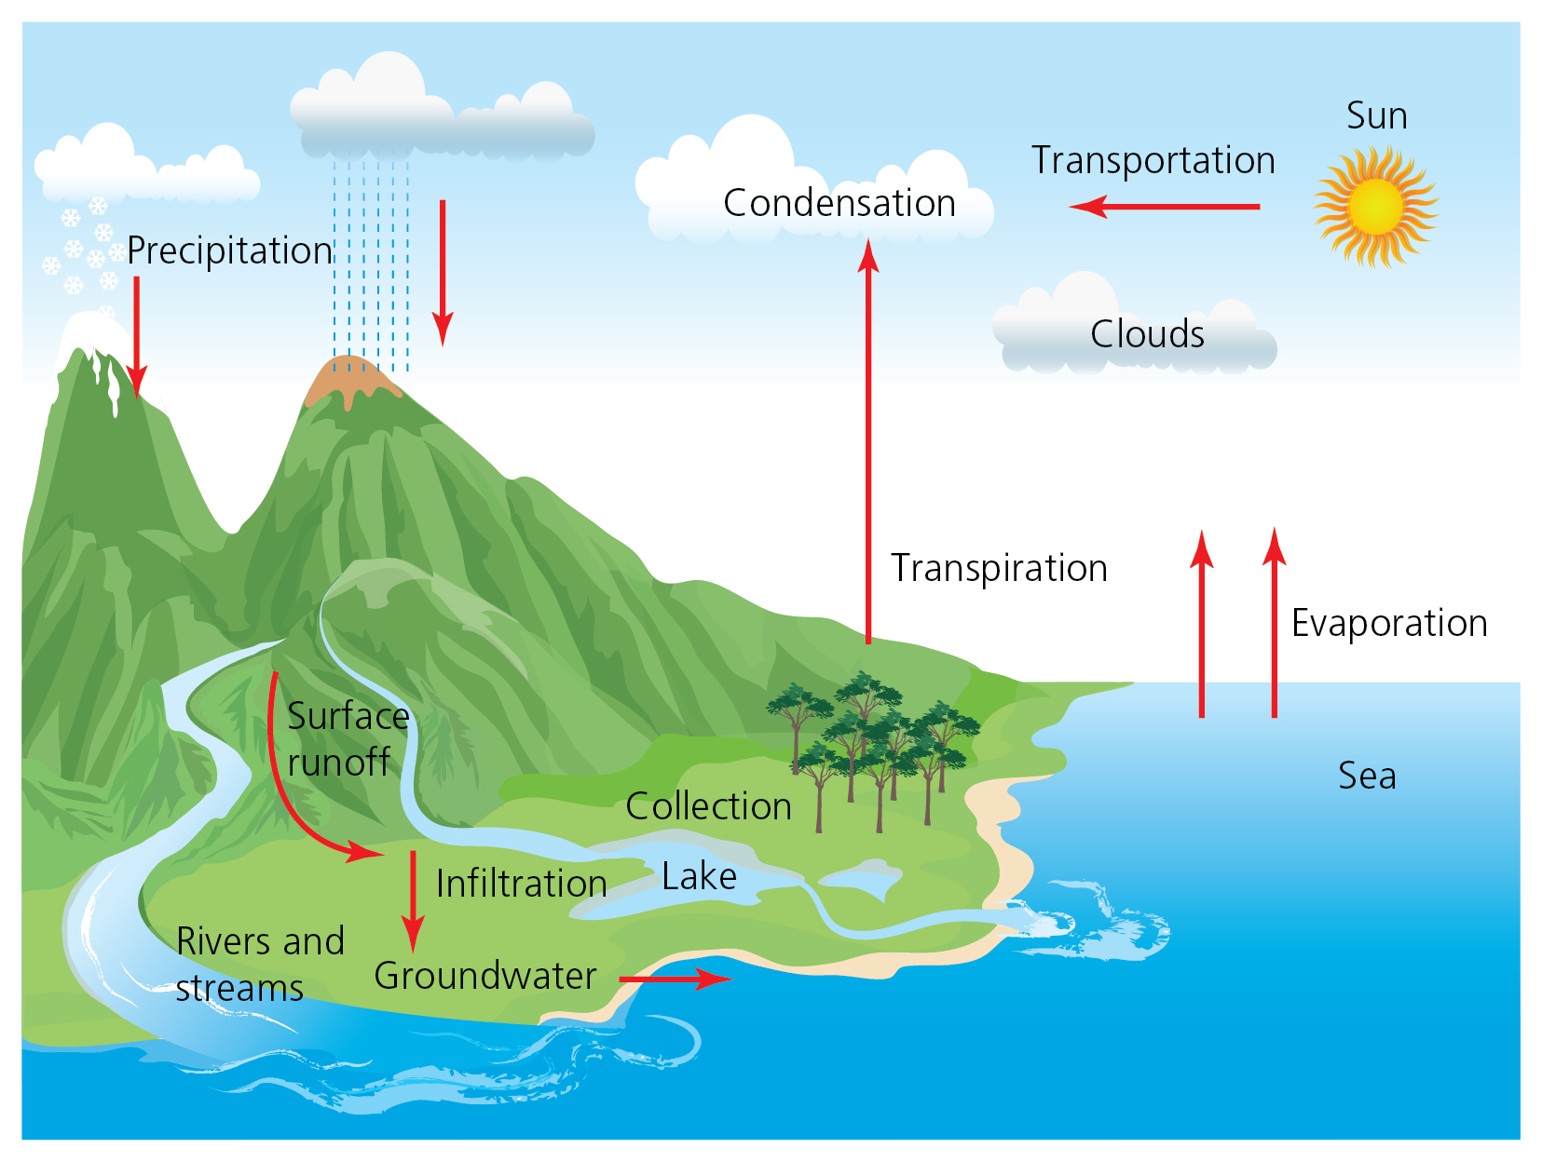
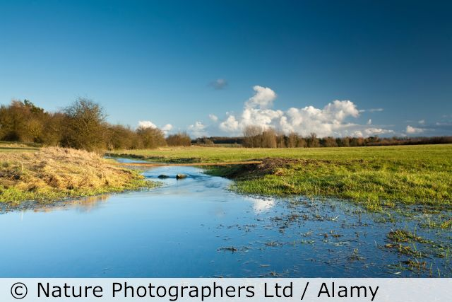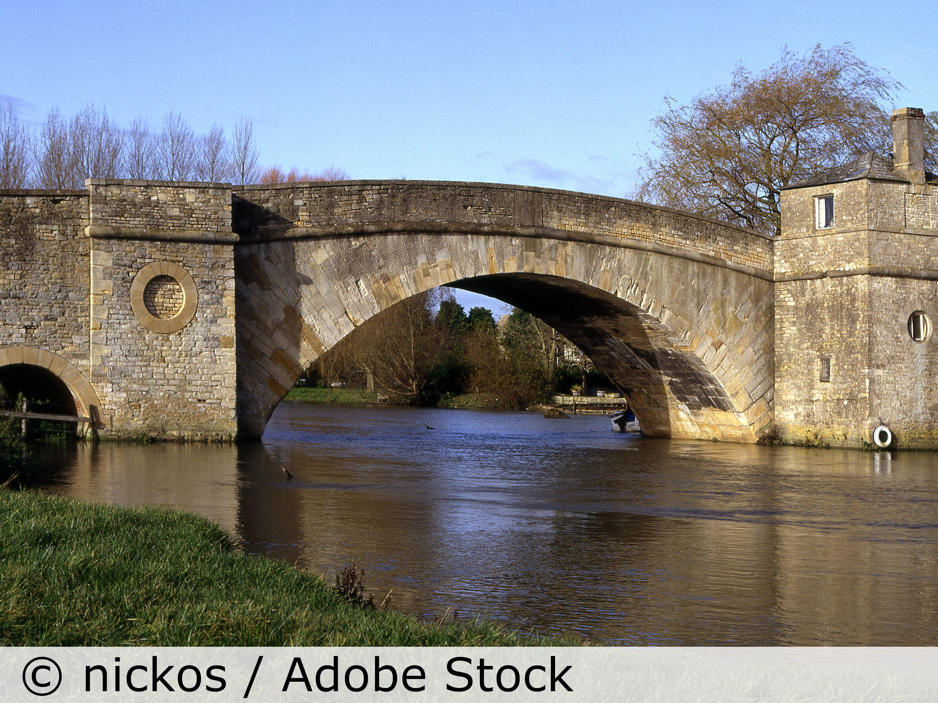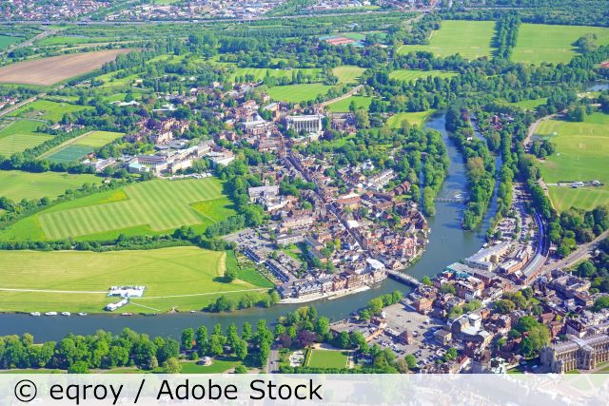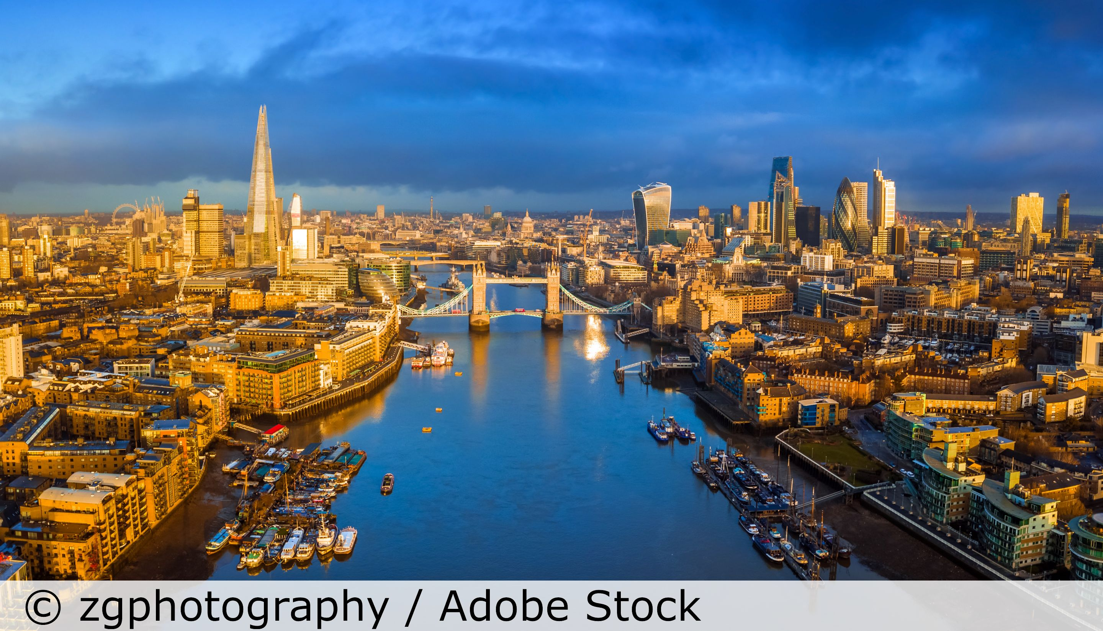

5 words to remember
estuary: where freshwater from rivers and streams mixes with salt water from the ocean in the widest part of a river’s course
mouth: where a river enters the sea or into a larger body of water, such as another river, a lake, reservoir, bay, gulf or ocean
source: where a river starts, upstream from the mouth
urban / rural: opposites that describe towns and cities (urban) and villages and hamlets or natural areas with no settlements (rural)
valley: the V-shaped area carved out the landscape by years of water moving downhill towards the sea; the Thames River basin is a good example

Look at the photos of the Thames. Then look at the descriptions of key world rivers below. Which aspects of these world rivers does the Thames have? Which does it not have? Which are you unsure about?

Using the words below, describe what happens in the water cycle. Use the diagram to the right as well to help you.

cloud coast condensation cool droplets evaporation flow groundwater heat lake land mountain ocean precipitation rain river sea snow stream sun surface runoff transpiration waterfall water vapour

Some key world rivers: River Thames: The source is in Gloucestershire and there are 45 locks on the non-tidal River Thames. Yangtze River, China: The Three Gorges Dam was built for hydro-electric power, to control floods and to help the river carry ships. It has created problems because of the weight of water, because of pollution in the reservoir and because people were moved (displaced). River Nile, Egypt: The Nile makes Egypt green as it has watered (irrigated) it since at least 4000 BCE. It also has dams (for example the Aswan) that help control the water. River Niger, Guinea / Mali / Niger / Benin: This flows away from the sea and into the Sahara desert, where it turns south east at Timbuktu and enters the sea in the Niger Delta in eastern Nigeria. Mississippi River, USA: This is used to move goods, such as oil and petroleum products, iron and steel, grain, rubber, paper, wood, coffee, coal, chemicals and edible oil. River Danube, Europe: The second longest river in Europe, the Danube has three capital cities on its banks. The river is a major focus for river cruises, as well as being a source of drinking water for 20 million people.

