Key takeaways
- North and South America are extremely varied continents. Every type of landscape imaginable is there.
- Many countries make up these continents, and there are many biomes (environmental regions); these include:
- The western coast: Comprising several biomes, including dry flat areas (plains), mountains with forests (Rocky Mountains) and the long Pacific Coast, there are also rainforests in the Northwest
- Great Plains / prairies: Huge areas of grassland and farming over five American states and two Canadian provinces
- Canadian Shield: A huge, ancient area in Canada with lots of rocks, lakes, and forests, it's like a special time capsule from long ago!
- Caribbean: A tropical region consisting of lots of islands and islets; its diverse landscapes include towns and cities, beaches, mountains and rainforests
- Eastern coastal strip: A long, narrow region along the Atlantic Ocean, stretching 2500 kilometres and featuring bustling cities, beautiful beaches, historic landmarks and diverse ecosystems
- In South America, as well as many coastal cities and settlements, there is the enormous country of Brazil; the Amazon Basin, which crosses eight countries; and the Andes mountains.
- Cities in the United States include Denver, Colorado; San Francisco, California; Chicago, Illinois; and Anchorage, Alaska.
- Cities in Canada include Vancouver, British Columbia; Yellowknife, North West Territories; Saskatoon, Saskatchewan; Quebec City, Quebec; and Minneapolis, Minnesota.
- Alaska is an American state and not part of Canada. ‘States' in the United States are referred to as ‘provinces' in Canada.
- Many of the buildings in North America are low-rise as there’s lots of space, compared to Europe. In cities, buildings constructed in the last 200 years often include clusters of skyscrapers for offices of big businesses. There are museums and theatres in large cities. Getting around is often by road rather than rail, so there are vast highways of many lanes to allow people to drive from city to city.

The northernmost point in Canada is 71° north, and the southernmost point is 53° north, of the equator.

The easternmost point of the Americas is in Brazil, at 34° west, and the westernmost point is in Alaska, United States, at 168° west, of the equator.

The UK ranges from Shetland, at 60° north, to the Isles of Scilly at 49° north, of the equator.
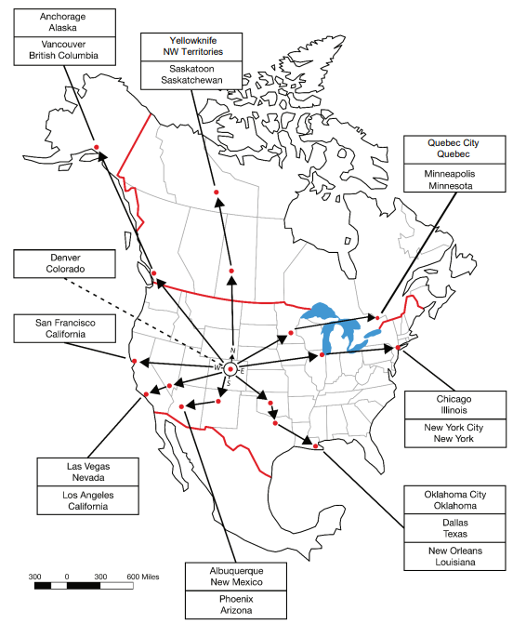

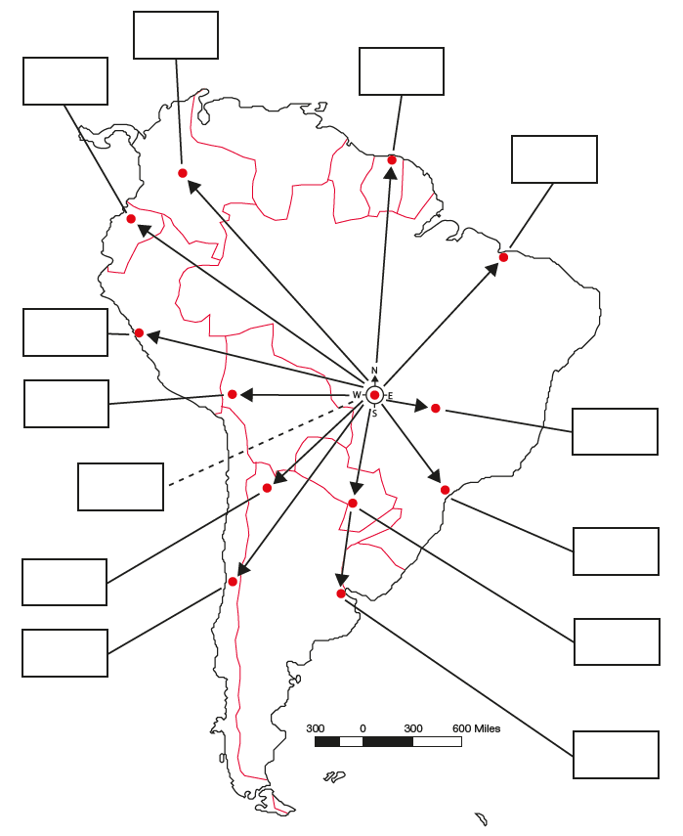
Label the major locations in South America.
Write down the locations in order from furthest north to furthest south, starting with Anchorage, Alaska.
Write a description of the two locations you have learned about that are the most different from each other, and the two that are the most similar, and say why.
5 words to remember
biomes: including deserts, forests, grasslands, tundra and aquatic environments, biomes are defined by the climate, soil, organisms, flora and fauna of a large area; each biome consists of many ecosystems whose communities have adapted to the small differences in climate and the environment inside the biome
Canada: the second-largest country in the world by land area
city: a location where lots of people come together to live, work and take part in leisure activities; growing / rearing food and making products often happens away from modern cities
continent: a huge land area with many countries in it, defined by certain unifying characteristics, which may be physical, human, or cultural
United States: the third-largest country in the world by land area

