Key takeaways
- The British Isles have a long coastline. The sea, the rivers that feed into it and the different rocks have created a mixture of headlands, cliffs, bays, beaches, dunes, marshes and estuaries. They are exciting to explore, and lots of wildlife live there.
- The UK has always been strongly linked with the sea. The Royal Navy is an example of this.
- Governing former empire countries such as India, Kenya and Canada meant that the UK could buy and sell products overseas (trade), which is what made the country wealthy.
- Fishing boats led to the development of docks, ports and harbours.
- Seaside resorts have existed since Victorian times, when people started going on holiday (tourism). Tourism has changed with the growth of air travel.
- Case studies:
Tourism in the past and today:
South-west England: Fishing was the main economic activity in the harbours of many small towns. Now there is less fish (due to over-fishing) and these places have had to change to find different activities to make money. Learning about the history of a place or walking or cycling in attractive locations are two reasons people visit.
Tourism today by air:
Spain: Benidorm on the Costa Blanca is an example of a change from a port to a tourist destination. Today it is famous for its hotels, beaches and skyscrapers, and it receives as many foreign tourists as Spanish. Tourism has dramatically changed the Costa Blanca.

Simple buildings support the fishing boats and workers.

Wide, sandy beaches and a coastline with farmland have a few buildings in places away from resorts and harbours.

Average temperatures range from +30°C to –10°C.

There is limited wildlife.

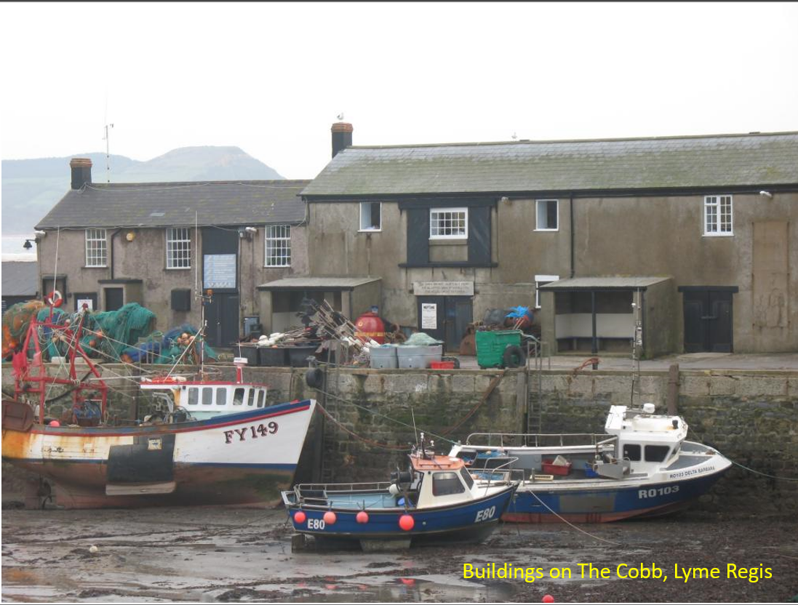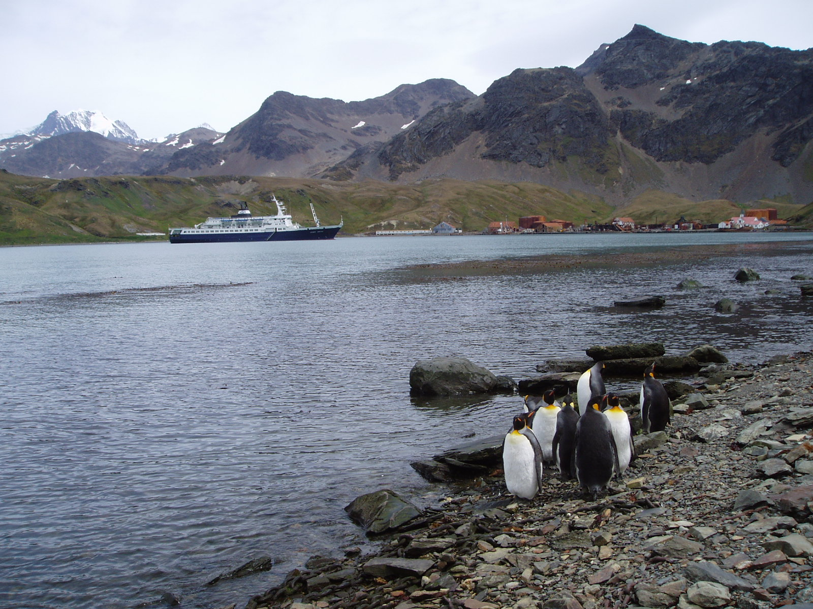

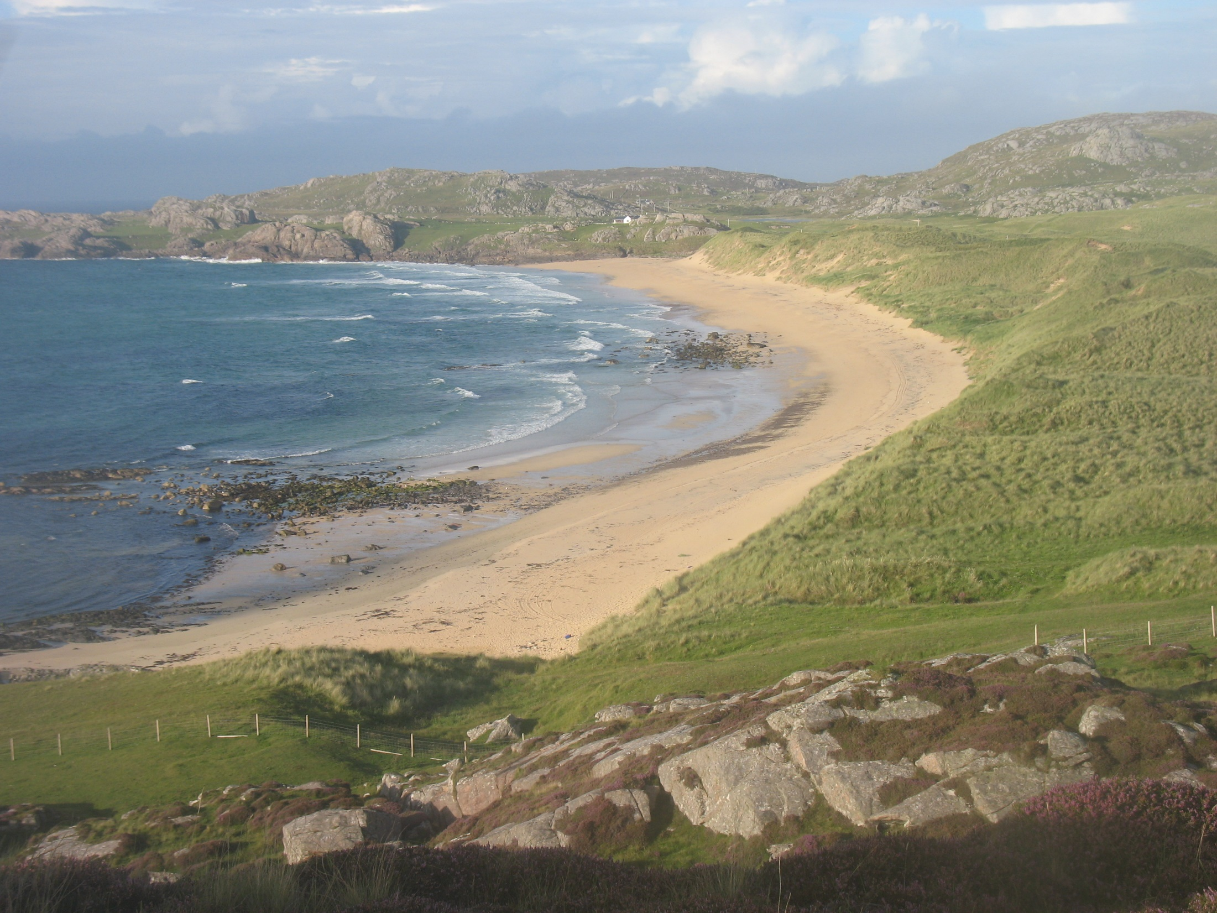

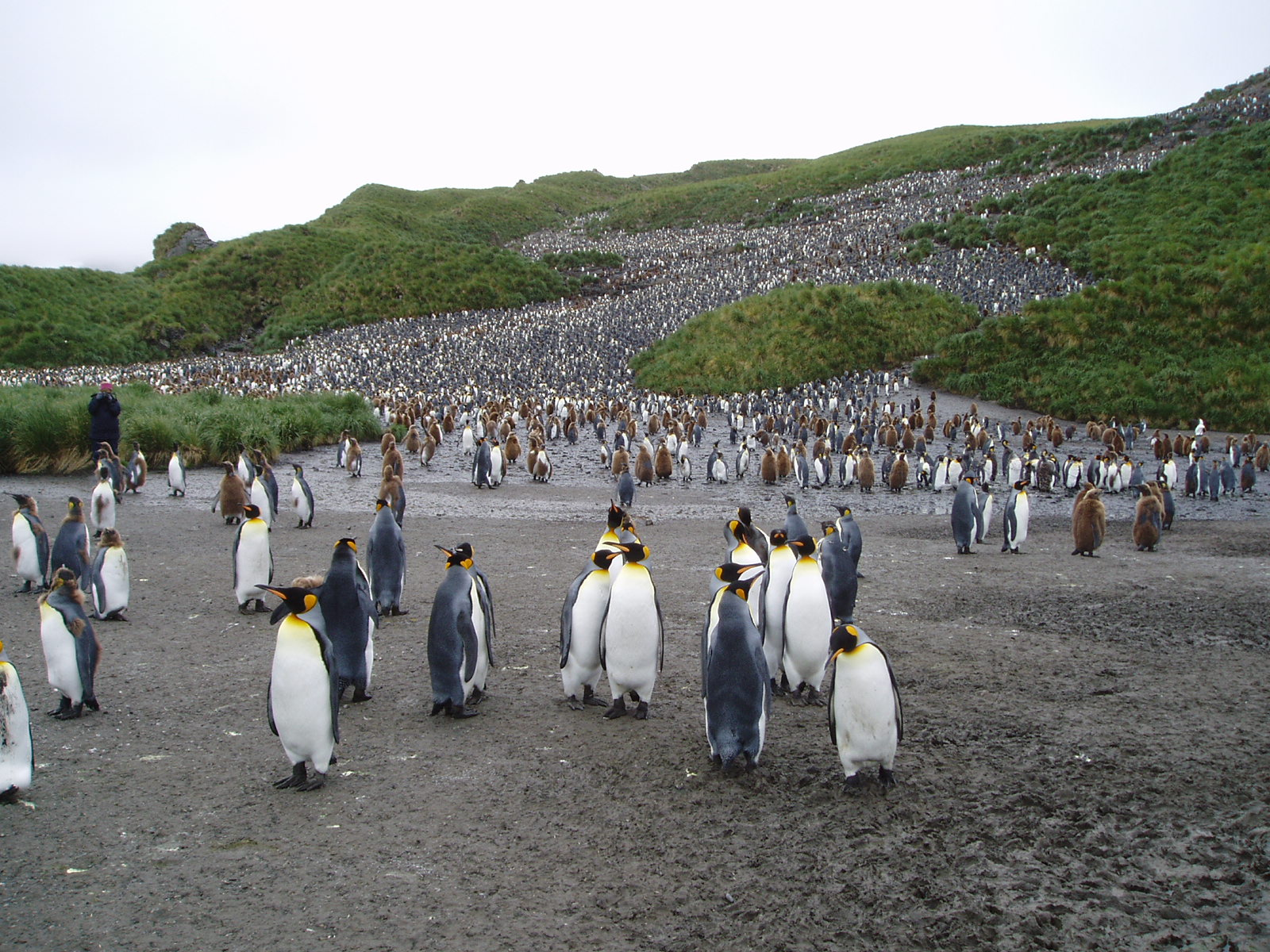
How do coastlines in the Northern Hemisphere 50° north of the equator (top pictures) compare to Antarctica at around 53° south (bottom pictures)?
5 words to remember
case study: an example of a location and its history
development: how a location changes over time
Northern Hemisphere: the area of the world north of the equator
tourism: travelling for fun or holidays
trade: buying and selling products, especially overseas to other countries, traditionally using ships alone, but also now by air
What is tourism like in Antarctica? How might this be different from England? Are there any considerations tourists should make before deciding to go?
Write a description of what you would see from aboard a boat looking at a busy harbour in south-west England. Consider human and physical factors.
Simple buildings support the tourist boats and workers.
It is below 0°C for 8 months of the year (April to November) and rarely gets above 1.5°C or below –5°C.

Snow melts and then quickly forms again. The sea is frozen for much of the year.

Wildlife includes seabirds, penguins and seals that feed in the surrounding waters.

