Key takeaways
- The world is a sphere. There are seven continents and five oceans.
- We can use a compass to tell us where are north, south, east and west. We use a compass with paper maps. In the UK, the Sun rises in the east and sinks in the west; this can help us work out directions too.
- The capital cities of the UK are London, Edinburgh, Cardiff and Dublin.
- Which local city is nearest to you? Are you near or far from a capital city; an area of industry; the coast; the countryside; mountains? Ask your teacher if you are not sure.
- We know where we are by looking at a map. We can do this on paper or on a computer. Some maps show a large area, some a small one, and we might be able to see our house and street.
- A globe shows the whole world, including longitude, latitude, continents, oceans, the equator and the North and South Poles.
- The two halves of the globe are called the Northern Hemisphere and the Southern Hemisphere.
- The Earth rotates every 24 hours, causing day and night. Parts of the world are in daytime while others are in night. When it is daytime in the UK, it is night-time in Australia; when it is afternoon in the UK, it is morning in the USA.

World map: physical
This shows types of land

Remember learning about biomes and what grows where and who might live in different locations? Many people live in the green areas of the world on this map. Very few live in the yellow parts of the world. Brown areas are very high up and include mountain areas like this one – the Himalayas.
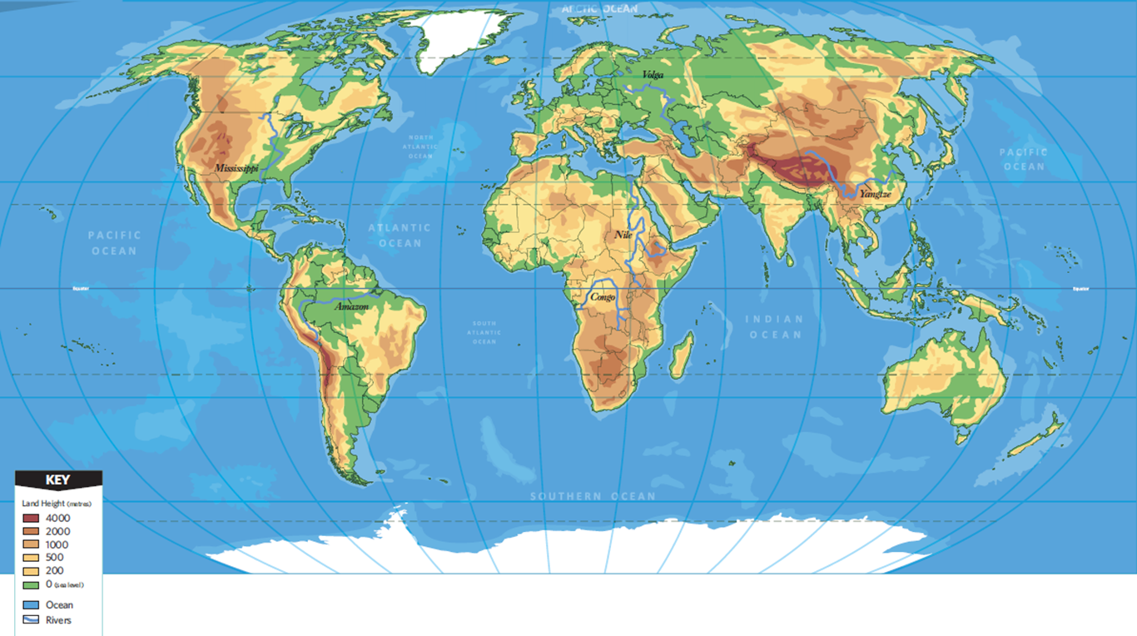
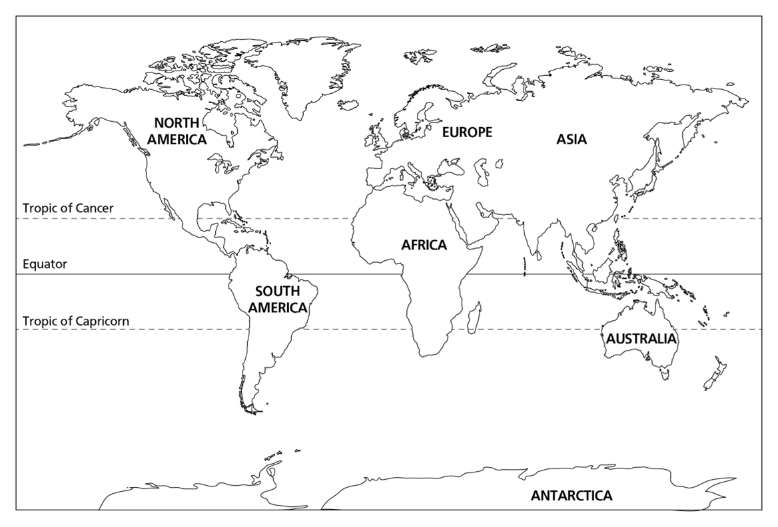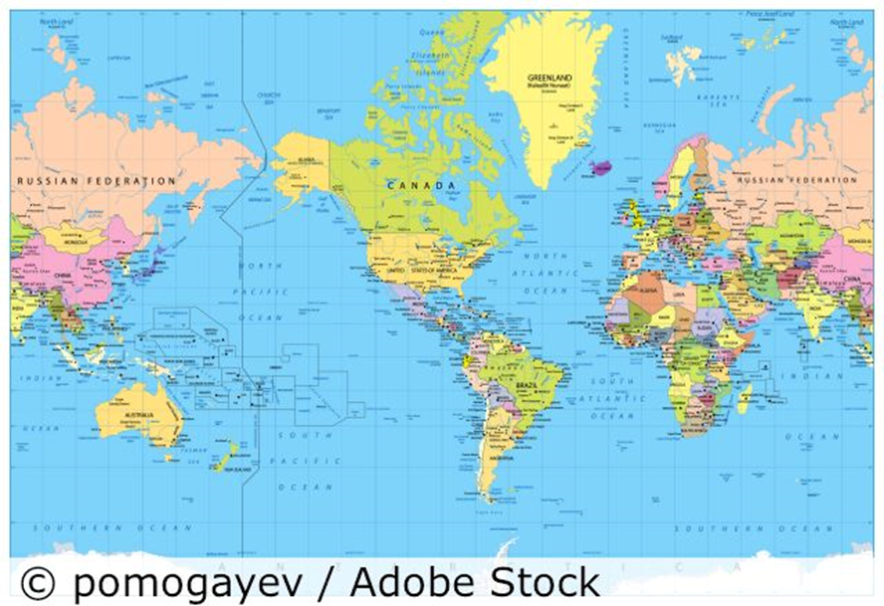

5 words to remember
biomes: including deserts, forests, grasslands, tundra and aquatic environments, biomes are defined by the climate, soil, organisms, flora and fauna of a large area; each biome consists of many ecosystems whose communities have adapted to the small differences in climate and the environment inside the biome
continent: a huge land area with many countries in it, defined by certain unifying characteristics, which may be physical, human or cultural
International Date Line: an imaginary line on Earth's surface that defines the boundary between one day and the next
latitude: imaginary circles on Earth’s surface that tell us how far we are north or south of the equator
longitude: imaginary arcs on Earth’s surface that tell us how far we are east or west of Greenwich in London
World map: political
This shows continent boundaries

The tropics are roughly 23° north and south of the equator.

Can you see the mistake on this map? Look at the names of the continents – which is different from what we have learned?
This shows the International Date Line and is a more detailed political map.

Why do you think the International Date Line zigzags near the 180° E–W line of longitude that goes through the Pacific Ocean, and is not straight down that line of longitude?
Look on a world map and write down five locations that are on the same longitude as you are.
Look on a world map and write down five locations that are on the same latitude as you are.

