Important things to know
- There are wonders of the world near to us and far from us. We should value what we have locally, whether that may be a large tree or an interesting building.
- There are wonders on each continent. The continents are: Antarctica, Asia, Oceania, Europe, North America and South America.
- Mountains are wonders. They can be high, long, wide, deadly, freezing and covered in trees, rocks or snow and ice.
- Everest is the highest mountain in the world. Some animals, such as the bar-headed goose, are wonders too, and get close to mountains including Everest.
- Rivers of the world include the Danube, Yangtze, Amazon, Nile and Mississippi. These rivers are all on different continents.
- The Suez Canal is a human-made wonder, carved out of the desert. It connects the continents of Asia and Europe. Christmas presents often come through here on enormous ships.
- Ancient wonders are those that are older than people who are alive today; they might even be thousands of years old.
- Modern means in the last 200 years.
- Geographic wonders made from rock, such as Uluru, were formed millions of years ago and were originally under the sea.

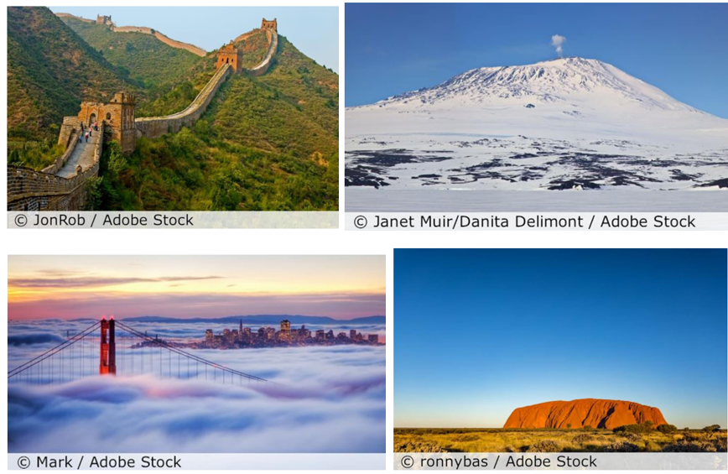

Asia: Great Wall of China | Antarctica: Mount Erebus
North America: Golden Gate Bridge, San Francisco | Oceania: Uluru, Australia

5 words to remember
continent: Antarctica, Asia, Oceania, Europe, North America, South America
river: Danube, Yangtze, Amazon, Nile, Mississippi
Suez Canal
Uluru
wonder

