Important things to know
- Our food comes from many locations in the UK and beyond. It can be fast, fresh, frozen or processed.
- Food needs to be planted, grown and processed (mixed with other things). It is reared and prepared for us before it is sold in a shop or supermarket.
- Food can be found near to you in hedgerows, fields and farms. Most food comes from enormous farms and factories.
- Milk is a natural product that comes from cows. Some foods come from plants and some from animals.
- Some plants we eat grow on trees, some in the ground in fields and others in large greenhouses.
- Food names sometimes give us an idea of where it has come from.
- Your area might be big or small, flat or hilly, with little water or by the coast, and different plants grow in each type of place.
- Wheat, barley and oilseed are all grown in the UK, and lots of land is given to cows or sheep to graze. They love all the green grass!

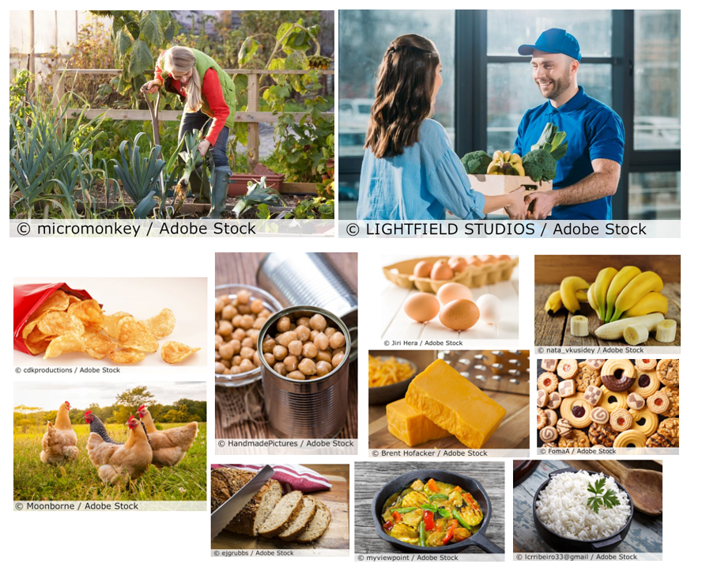

Growing food is hard work. Here is an allotment or garden where you can grow enough for one family. Large farms produce food for many people. | We get food in lots of different ways. We can now order food right to our homes from a phone or computer!
There are many types of food, such as fast, fresh, frozen and processed. Can you tell which is which?

5 words to remember
fast
food
fresh
frozen
processed

