Important things to know
- Geographers go on journeys to cities, countries and continents. Many animals do too!
- The continents’ names are: Asia, Oceania, Europe, Antarctica, North America and South America.
- Around each continent are seas and oceans. These are the Arctic, Southern, Pacific, Atlantic and Indian.
- Some people live near to precious land animals, but we don’t always care for wildlife like we should. What we do makes a difference.
- Penguins and elephants are amazing. Their natural habitat is not in the UK, but you may see them in a zoo.
- African elephants eat plants, can live a long time and are the largest land animal.
- Small sharks live in the sea around the UK. Even whale sharks, which are the size of a bus and live around Australia in Oceania, are harmless to us.
- Birds called swallows fly across the world. They fly over land, eating and drinking as they go, often not stopping until they reach the south of Africa.

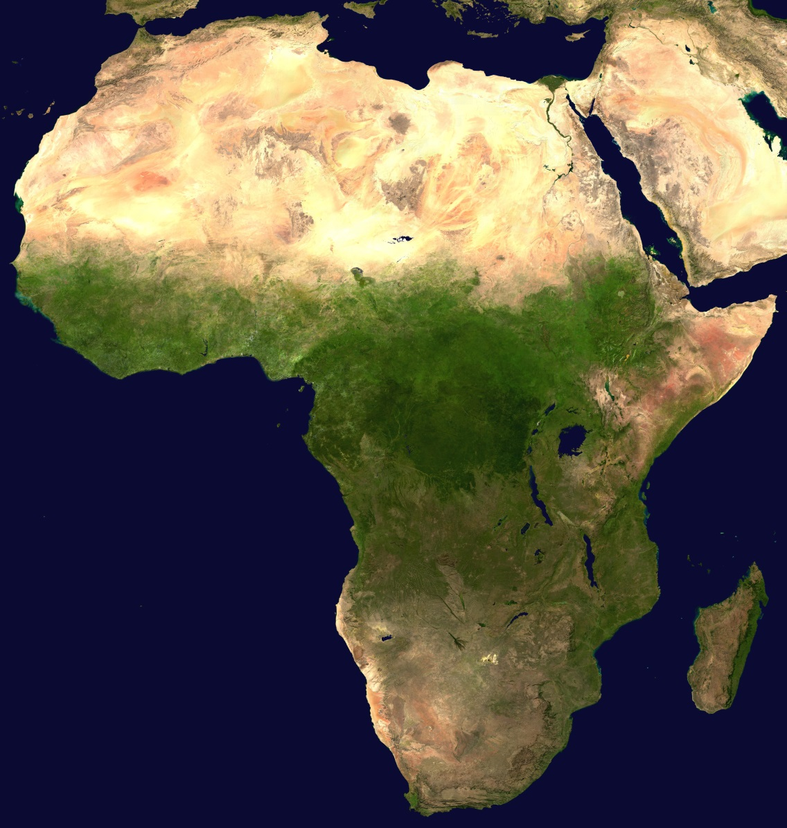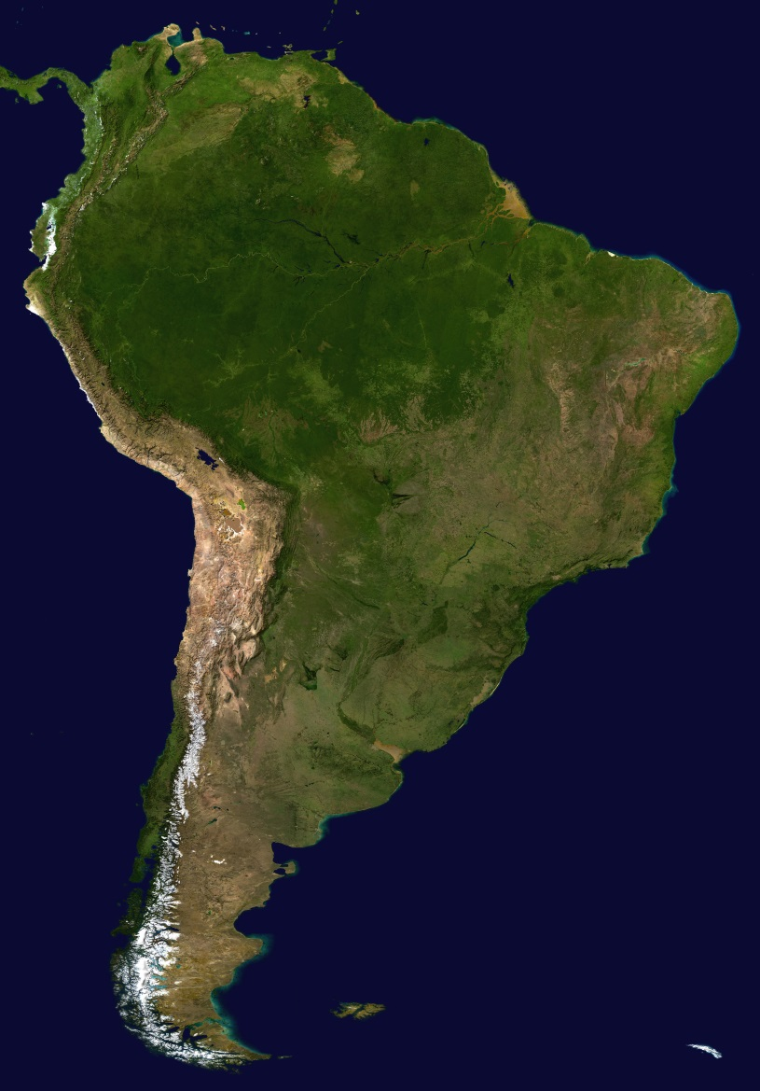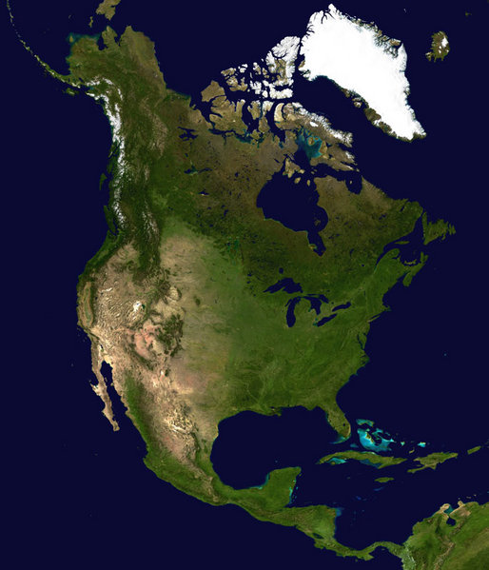

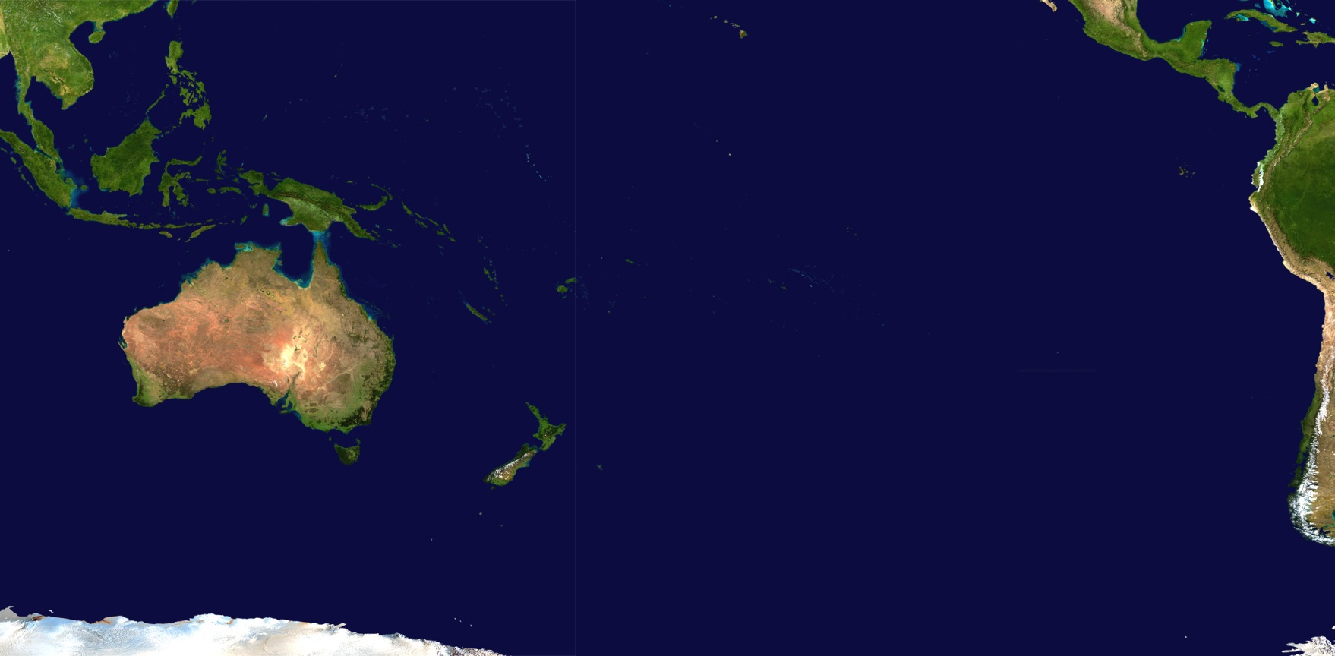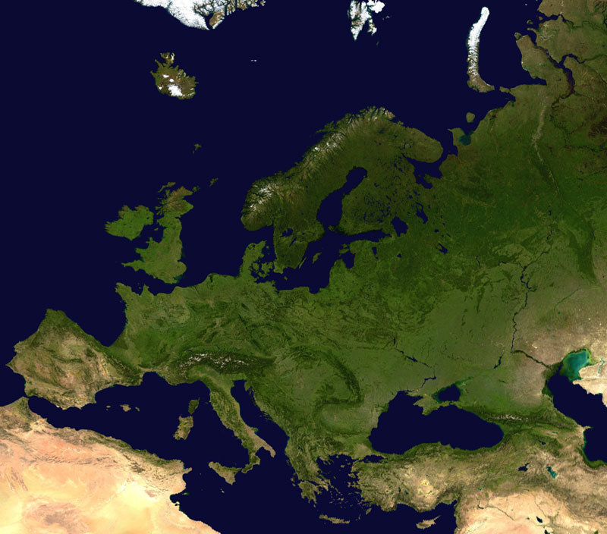

The continents seen from a satellite. The colours show how hot, dry, cold or wet they are. Where we live in the UK is in the Northern Hemisphere in Europe, which is mostly green and is a good place to live as we have four seasons.

Africa | South America |  | North America
Oceania |  | Europe

Antarctica is not shown.

Do you know what it looks like?
5 words to remember
continents
elephant
penguin
shark
swallow

