Stone Age to Iron Age
Romans
Maya
Ancient Egypt
BC
AD
3000 | 2500 | 2000 | 1500 | 1000 | 500 | 500 | 1000 | 1500 | 2000 | 2500
Where does Ancient Greece fit in with other civilisations we have studied?

Ancient Greece
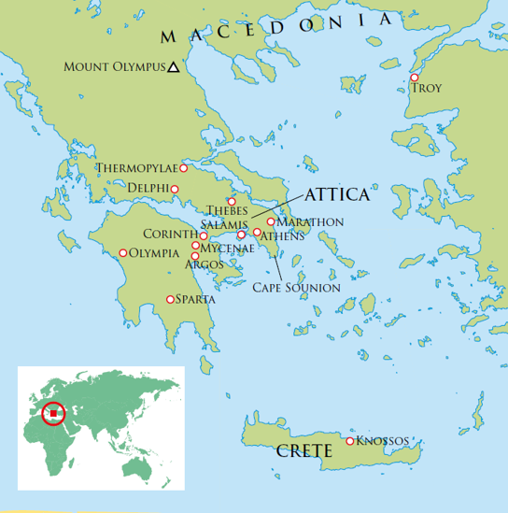
Key takeaways
- Ancient Greece was made up of a number of city-states.
- The most important city-states were Athens and Sparta.
- These city-states sometimes worked together against a common enemy.
- They had different forms of government.
- In Athens, they had a democracy where the citizens voted for the government.
- In Sparta, they had a monarchy with two kings.
- We know about Ancient Greece from using a variety of sources, including buildings, artefacts, written evidence and myths.
- Ancient Greeks were pioneers in many areas, including mathematics, art, philosophy and science.
- Many innovations from Ancient Greece can still be seen today, for example in architecture, medicine, mathematics, language and drama.
- Not all aspects of Ancient Greek life should be admired, for example their treatment of women, children, disabled people and animals and their use of slavery.

Athens today – Parthenon at Acropolis

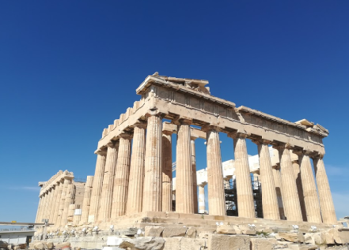

The most important legacy from ancient Greece is ………………….….……………………………………………………………………………………………………………………………………… because ………………………………………………………………………………………………………………………………………………………………………………………………………………………………………………………………………………………………………………………………………………………………………………………………
The most important difference between Ancient Athens and Sparta is ………………….……………………………………………………………………………………………………………………………………………………………………………………………………………… because ……………………………………………………………………………………………………………………………………………………………………………………………………..

5 words to remember
citizen: someone belonging to that place or area
democracy: where the people choose the government
legacy: something resulting from a time in the past
myth: a traditional story – particularly one to explain why natural things take place
pioneer: to be the first at something and open the way for others

Ruins of ancient Sparta

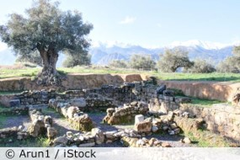

The Ancient Olympic Games were first held at Olympia in 776BC. This shows a victory ceremony.



