Stone Age to Iron Age
Romans
Maya
Egypt
BC
AD
3000 | 2500 | 2000 | 1500 | 1000 | 500 | 500 | 1000 | 1500 | 2000 | 2500
Where does the Maya fit in with other civilisations we have studied?

Key takeaways
- Maya people lived in Meso-America (Central America) in the area called Mexico and Guatemala.
- The Maya civilisation was a Stone Age culture as they didn’t have metal.
- The Maya civilisation formed a society of city-states.
- Maya people made many technological advances and established a huge trading empire.
- The Maya people developed a writing system based on symbols called ‘hieroglyphs’.
- The Maya people built pyramids to worship their gods and offer sacrifices.
- Maya people worshipped up to 300 gods, each one doing a different job.
- There are many theories why the population of Maya cities disappeared around 900AD.
- We know about the Maya civilisation from archaeological remains and the people living in the area today.
- We use the term ‘Maya’ not ‘Mayan’. ‘Mayan’ is used only to describe the language.

The Maya people built pyramids. Here is one at Tikal in Guatemala.

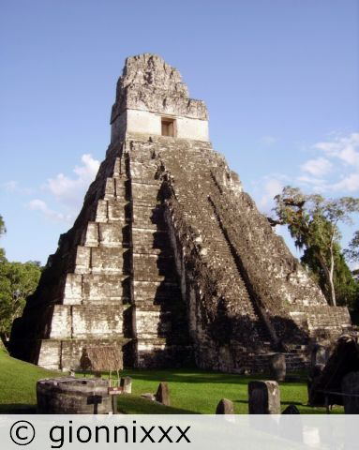

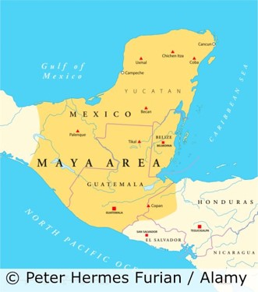

The main reason we should remember the Maya people is that
………………………………………………………………………………………………………………………………………………………………………………………………………………………………………………………………………………………………………………………………………………………………………………………………………………………………………………………

The Maya civilisation is similar to the
…….……………………………
because
………………………………………………………………………………………………………………………………………………………………………………………………………………
However, they differ because
……………………………………………………………………………………………………………………………………………………………………………

5 words to remember
city-state: an independent self-governing state formed of a city and its surrounding area
sacrifice: to make an offering to a god
technology: developing knowledge and tools to make people’s lives easier
theory: an idea about why something happened
trade: the buying and selling of things like food
The Maya people lived in an area covered by rainforest.

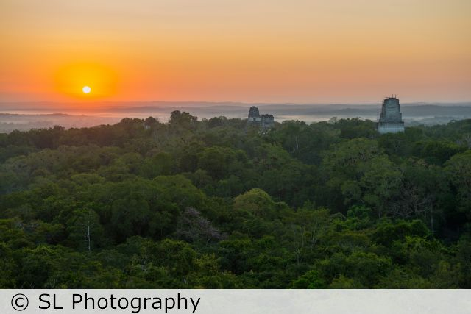
Use an atlas to locate Meso-America on a map of the world.

