1595 Walter Raleigh sailed to find El Dorado
1948 MV Empire Windrush set sail from the Caribbean
10 April 1912 RMS Titanic set sail from Southampton
1500
1600
1700
1800
1900
2000

December 1938–September 1939 Kindertransport
Key takeaways
- You have already learned about many different journeys in the units you have studied, for example journeys of explorers, invaders and settlers, including Romans, Anglo-Saxons and Vikings.
- People go on a journey for many different reasons.
- Some make a choice to go on a journey, like the passengers on the MV Empire Windrush.
- Others are forced to go on a journey to survive, like the children on the Kindertransport.
- Some travellers have a positive experience when they arrive at their destination.
- Others, like those on the MV Empire Windrush, may face discrimination.
- We can find out about journeys using many different sources of evidence, depending on the time period being studied.
- Songs and poems can be used to find out about the past, for example those of the Windrush passengers.
- People continue to travel to the UK today for many different reasons, including finding work and escaping persecution in their own country.
- People have also left the UK as migrants. Often this is for economic reasons, for example passengers on the RMS Titanic. Some people continue to leave today.

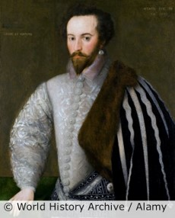
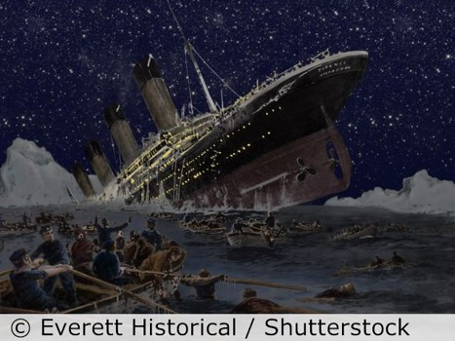

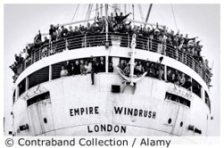
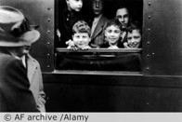
They travelled from….
This is a representation of the sinking of RMS Titanic. It was sailing to America with 2200 passengers.

Walter Raleigh was a sailor and explorer who lived during the Tudor and Stuart periods.

492 passengers on the Empire Windrush came to settle in the UK. Sadly, they faced prejudice and discrimination from some.
Facing anti-Semitism in their own country, many Jewish children came to Britain as refugees. They were part of a movement of almost 10,000 children to Britain from Central Europe, known as the Kindertransport.
One group of people who have settled in my local areas is
………………………………………....………………………………………
They travelled from
…………..……………………………..………………………………………………………………………………
They moved here because
…………………………………………………………………………………………………………………………………………………………………………………………………………………………………………………………………………………………………………………………………

5 words to remember
anti-Semitism: discrimination against Jewish people
discrimination: unfair treatment of someone because of their religion, race, and so on
migrant: someone who moves from one country to another, often to find work
prejudice: an unfair dislike for someone because of their religion, race, and so on
refugee: someone who is forced to leave their country

People go on journeys for many reasons, including
…………………..………………………………………………………………………………………………………………………………………………………………………………………………………………………………………………………………………………………………………………………………………………………………………

