787AD Viking raids then settlement

BC
AD
Stone Age to Iron Age
3000 | 2500 | 2000 | 1500 | 1000 | 500 | 500 | 1000 | 1500 | 2000 | 2500

Vikings
1066 Battle of Hastings

Anglo-Saxons
Romans
g
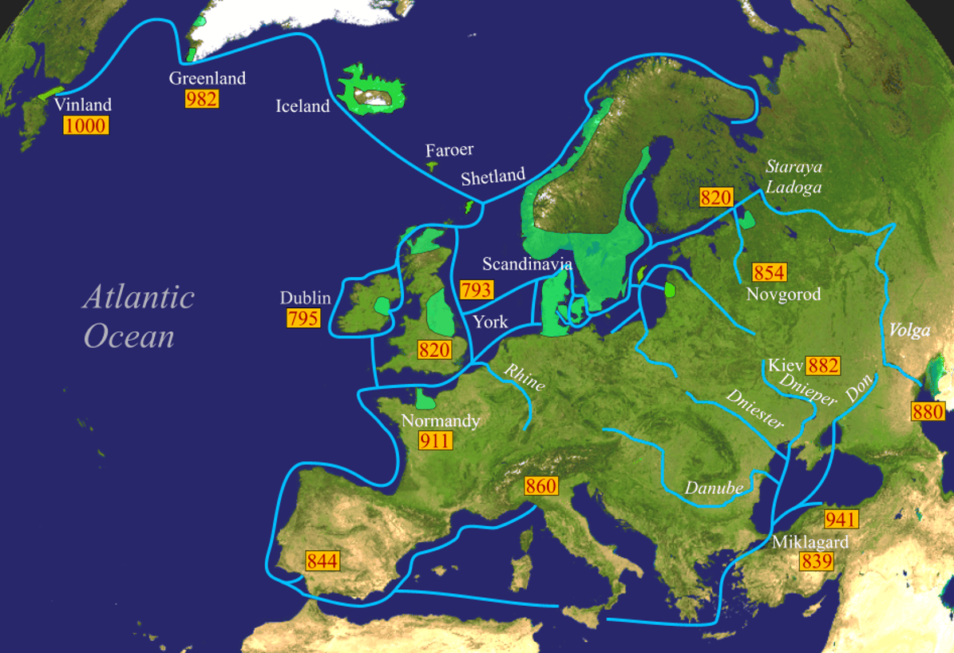
Key takeaways
- Viking means ‘pirate’ or ‘raider’. Vikings came from Scandinavia (Norway, Sweden, Denmark).
- Not all Viking people were raiders; many were farmers, traders and craftspeople.
- Vikings migrated from their homeland for a number of reasons.
- Some included push factors – where they came from was overpopulated and there was not enough food.
- Pull factors included wealth and a better climate.
- Vikings settled in many places, not just in Britain.
- They mainly settled in rural areas in the East of England as these were the first places they encountered.
- We know about Vikings by studying archaeological remains, studying the Viking sagas and reading written accounts.
- Some accounts were written by other groups, like Anglo-Saxons, a number of years after the events took place.
- Historians continue to review their interpretation of what Viking people were like.

Viking journeys
Main settlement areas

Map showing Viking journeys

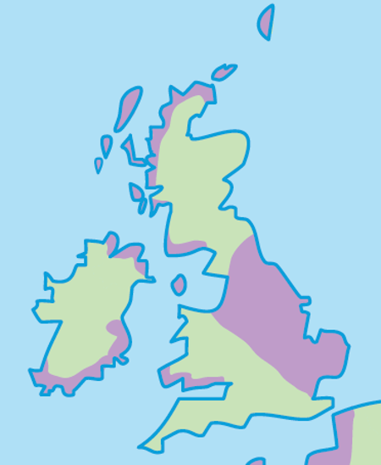
The most important reason the Vikings settled in Britain was that
………………….………………………………..……………………………………………………………………………………………………………………………………………………………………………………………………………………………………………………………………………………………………………………………………………………………………………………
The nearest Viking settlements to my home are
…………………………………..…………………………………..………………………………..
I know this because
….……………………………………………………………………………………………………………………………………………………………………………………………………………………………………………………………………………………………………………………………………………………………………………………………
5 words to remember
interpretation: a description or explanation of something in the past based on sources of evidence
migrate: to move from one place to another
raid: to enter a place by force to steal something
rural: countryside areas, usually focused on farming
saga: a story that tells a heroic adventure

Map showing Viking settlement (purple shading)

