Stone Age to Iron Age
Romans

AD
Anglo-Saxons
Viking raids then settlement
BC

3000 | 2500 | 2000 | 1500 | 1000 | 500 | 500 | 1000 | 1500 | 2000 | 2500

Key takeaways
- The Roman army left Britain around 410AD.
- Anglo-Saxons had started to raid Britain before the Roman army left.
- Anglo-Saxons started to settle in Britain as the country was fertile.
- Anglo-Saxons came from Germany, Holland and Denmark.
- Anglo-Saxons were originally pagan, but they gradually converted to Christianity.
- Anglo-Saxons did not call the time that they lived the Dark Ages.
- Historians called the Anglo-Saxon period a Dark Age, as they thought it was very different from civilised Roman Britain.
- The archaeological remains at Sutton Hoo and the Staffordshire Hoard tell us a lot about Anglo-Saxon people. They have made historians change their minds about a Dark Age.
- We can also find out about Anglo-Saxons from the story of ‘Beowulf’.
- From 793CE, Vikings raided and then settled in Britain.

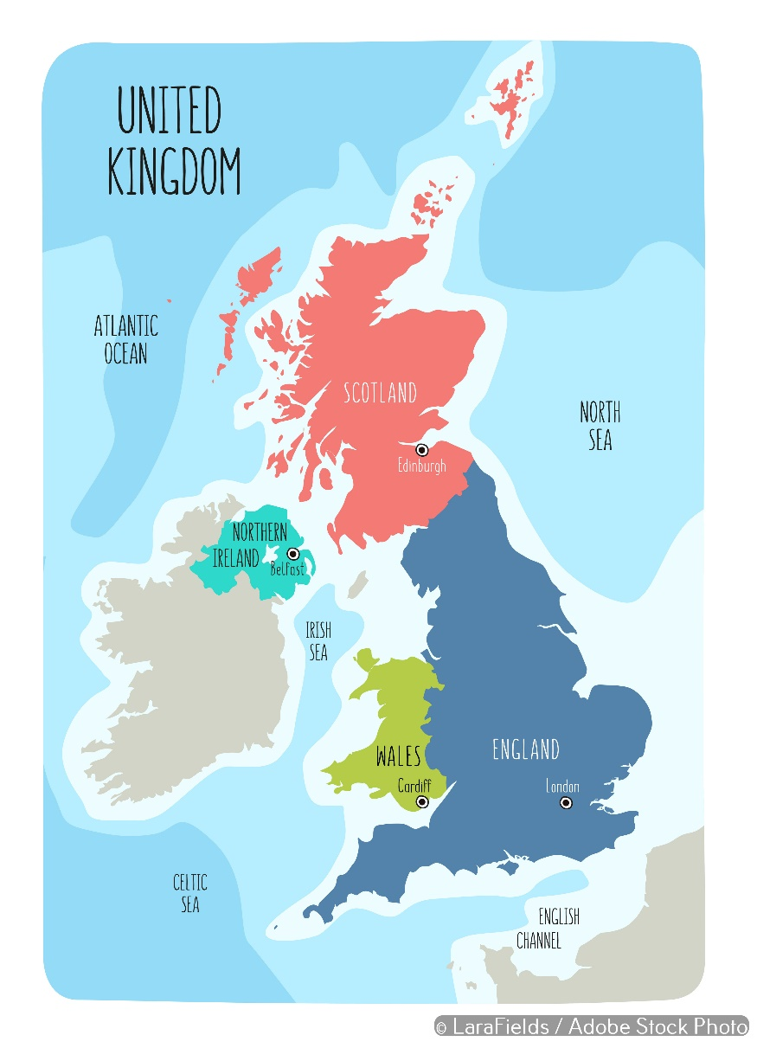
The Staffordshire Hoard is one of over 300 Anglo-Saxon hoards found across Britain. Almost 4000 items were found there.
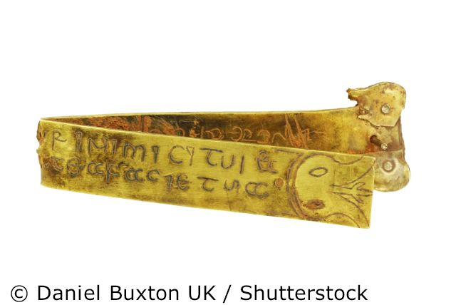

The main reason that the Anglo-Saxon period is / is not a Dark Age is:
…………………………………………………………………………………………………………………………………………………………………………………………………………………………………………………………………………………………………………………………………………………………………………………………………………………………………………………………………………………….
Our most important local link to the Anglo-Saxon period is:
………………………………………………………………………………………………………………………………………………………………………………………………………………………………………………………………………………………………………………………………………………………………………………………………………………………………………………………
5 words to remember
fertile: a place where plants and crops grow easily
hoard: hidden treasure stored away
pagan: a term used for someone who worshipped many gods
period: a time in history
settle: to make a home somewhere
Sutton Hoo is the largest Anglo-Saxon burial mound in England. This iron helmet was found in the burial chamber.

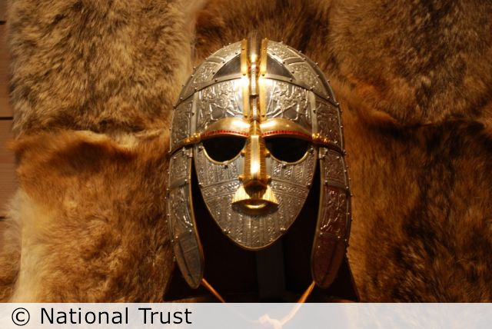
Can you add your location to the map?

