1787 Transportation to Australia begins
1868 Transportation to Australia ends
1718 Transportation to America begins
1700
2000
1750
1800
1850
1900
1950

1986 Corporal punishment banned in state schools in England
1776 Transportation to America ends
1868 Last public hanging in England
Can you add some of the other key dates to the timeline?

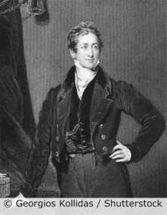
Key takeaways
- Attitudes and values about what is a crime and how it should be punished have changed over time.
- Suffragettes campaigned for women’s suffrage. They were considered criminals and put in prison. Now we celebrate their achievements.
- Some actions are still considered crimes, but the punishment is less or more severe.
- Other crimes are no longer crimes at all, for example celebrating Christmas.
- In the early 1800s, over 200 crimes were punishable by death as people thought this would stop people committing the crimes.
- Over the years, the number of crimes punishable by death was dramatically reduced. In 1965, the death penalty for murder was banned in England.
- In the 1700s, transportation to the colonies was a popular punishment.
- Prisons are a form of punishment, but they now also work to re-educate people who have committed crimes.
- We can find out about crime and punishments from a range of sources, depending on the time period.
- This includes visiting old prisons, reading newspaper reports and looking at drawings and photographs.

Robert Peel formed the Metropolitan Police force in 1829.

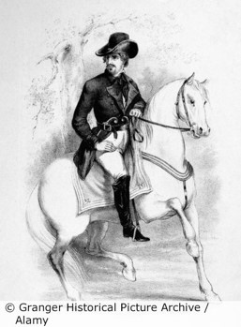

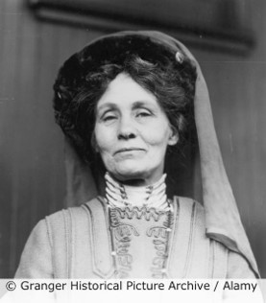
A local suffragette / suffragist is
………………………………………………………………………..
She should be remembered because
…………………………………………………………………………………………………………………………………………………………………………………………………………………………………………………………………………………………………………………………………………………………………………………………………………………………………………

The most important change in crime and punishment is
……………………………………………………………………….………………………………
because
…………………………………………………………………………………………………………………………………………………………………………………………………………………………………………………………………………………………………………………………………………………………………………

5 words to remember
crime: what happens when someone breaks a law
laws: set of rules for people to follow
punishment: a penalty for doing something wrong
suffrage: to be able to vote for who you want to govern the country
values: things you think are important for the way you live your life

Dick Turpin was a highwayman. He was executed in York in 1739.

Emmeline Pankhurst founded the Women’s Social and Political Union (WSPU) in 1903.

