Add the current date to the timeline.

Stone Age to Iron Age
BC
AD
3000 | 2500 | 2000 | 1500 | 1000 | 500 | 500 | 1000 | 1500 | 2000
Roman Britain
55BC | 54BC | 43AD | 61AD | 122AD | 410AD
Attempted invasions by Julius Caesar |  | Emperor Claudius invades | Boudicca’s revolt | Hadrian’s Wall built | Romans leave Britain
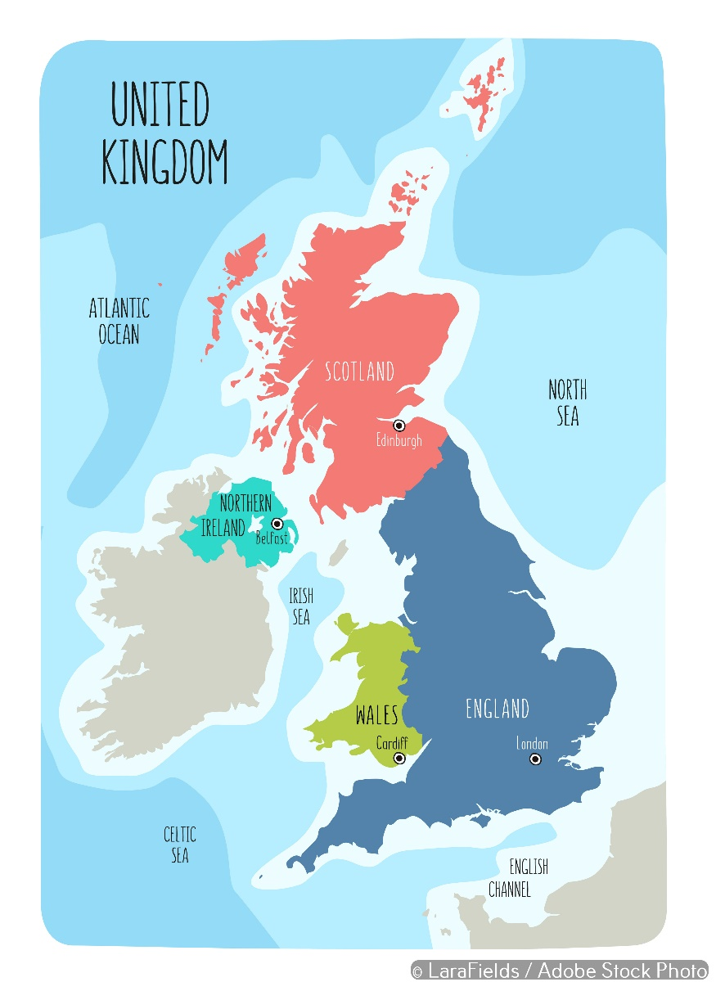
Key takeaways
- Julius Caesar had two unsuccessful attempts to invade and conquer Britain in 54 and 55BC.
- Emperor Claudius, the leader of the Roman Empire, planned a successful invasion in 43AD.
- Claudius wanted resources from Britain. He thought a successful invasion would make him popular.
- We know about Roman Britain by visiting archaeological sites and looking at remains.
- In many parts of Britain, there are Roman sites, including roads, villas and forts.
- Hadrian’s Wall is the most famous Roman site.
- We can also read written accounts about Roman Britain, for example the Vindolanda Tablets.
- In Roman times, most people lived in the country. Their lives didn’t change very much.
- Roman people brought many positive things to Britain. Their impact can still be seen today.
- The Roman period did not end abruptly in 410AD. Some Roman people continued to live in Britain.

Hadrian’s Wall was built to control the North.
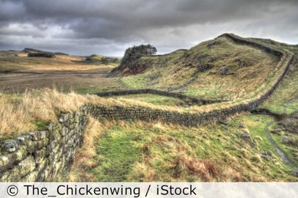

5 words to remember
conquer: to defeat and take over through force
emperor: the ruler of an empire
empire: a group of countries ruled over by another country
impact: to make a positive or negative change on something
invade: to enter and take over a country through force

An important local Roman site is
…………………………………………………………………………………………………………………………………………
because
……………………………………………………………………………………………………………………………………………………………………………………………………………………………………………………………………………………………………………………………………………………………………………………………………………………………………………………………………………………………….

The most important change that took place after the Roman invasion was
…………………………………………………………………………………………………………………………………………because…………………………………………………………………………………………………………………………………………………………………………………………………………………………………………………………………………………………………………………………………………………………………………………………………………………………………………………….

Boudicca and the Iceni tribe led an unsuccessful revolt against the Roman people. The final battle was possibly at Mancetter in Warwickshire.
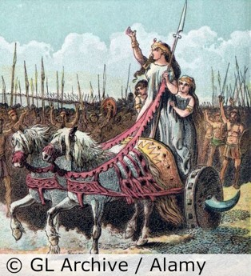

Claudius’s invasion landed at Richborough.
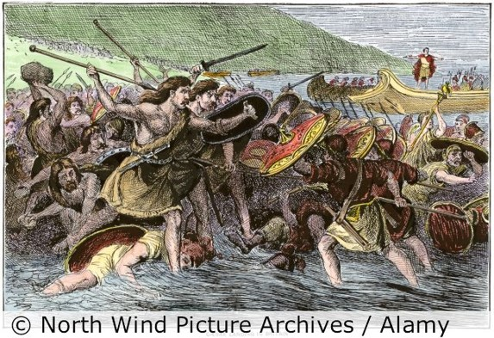

Can you add your location to the map?

