Sumer
Shang
Indus valley
Egypt
BC
Ancient civilisations
What was happening in Britain during this period?

AD
3000 | 2500 | 2000 | 1500 | 1000 | 500 | 500 | 1000 | 1500 | 2000 | 2500

The Great Pyramid of King Khufu (Cheops) at Giza

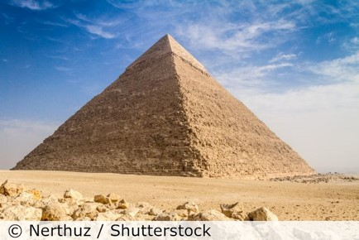

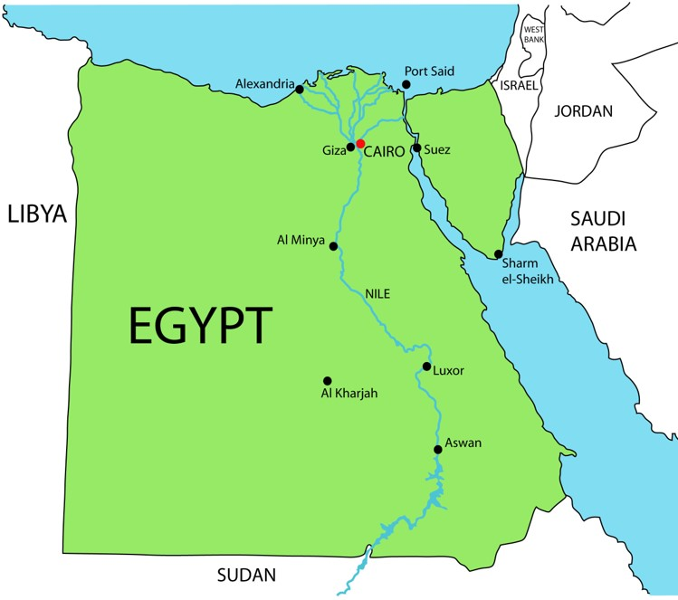
The River Nile was important. Egyptian people built irrigation systems along the Nile.
Key takeaways
- We can find out about the Ancient Egyptian civilisation by studying archaeological remains and writing.
- The River Nile was important because it made the land fertile, so Egyptian people could grow crops. It was also used for transport.
- Society was structured with the pharaoh at the top and enslaved people at the bottom.
- Most people in Ancient Egypt were farmers.
- Ancient Egyptian people worshipped over 2000 gods and goddesses.
- Ancient Egyptian people believed in an afterlife.
- Archaeologists are able to read hieroglyphics following the discovery of the Rosetta Stone.
- Howard Carter discovered the tomb of Tutankhamun in November 1922.
- Many museums in the UK have an Ancient Egyptian collection.
- Ancient Egyptian people had many achievements in such areas as farming, building, religion, medicine, writing, mathematics and crafts.

Three features Ancient Egypt, Shang Empire, Indus Valley and Sumer all had in common are
…………………………………………………………………………………………………………………………………………………………………………………………………………………………………………………………………………………………………………………………………………………………………………………………………………………………………………………………………
The Ancient Egyptian people’s greatest achievement was
…………………………………………………………………………………………………………………………………………
because………………………………………………………………………………………………………………………………………………………………………………………………………………………………………………………………………………………………………

Modern map of Egypt

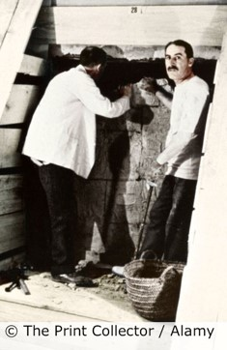
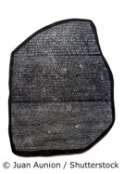
5 words to remember
achievement: something special reached through hard work or skill
civilisation: a group of people living together, who have advanced ways of living, communicating and working
irrigation: to bring water from rivers or lakes to fields
pharaoh: the supreme ruler of Ancient Egypt
pyramid: a monument providing a tomb for the pharaoh

The Rosetta Stone was discovered in 1799.

The tomb of Tutankhamun was discovered in 1922.

