BC
Stone Age
Our living memories
AD
Mesolithic
Neolithic
Paleolithic

Bronze Age
Iron Age

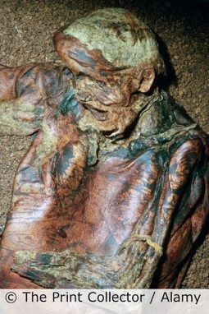
Key takeaways
- The move from the use of stone to bronze and then to iron was gradual.
- We can find out about the Bronze and Iron Ages by interpreting archaeological remains.
- Burials like the Amesbury Archer are very useful for finding out how people lived and what they thought was important.
- Hill forts like Maiden Castle were built in the Iron Age.
- Hill forts were built for defence and also served as places for different tribes to meet and trade.
- Bronze was better than using stone because it was easier to shape, was stronger and could be used again.
- Iron was better than bronze because it was more common, lighter and harder.
- People began to use horses for transport in the Bronze Age.
- Sites like Butser Farm use archaeological evidence to reconstruct what life was like.
- The developments in use of materials in this period impacted on many areas, including agriculture, crafts, warfare, and so on.
Lindow Man
was buried
during the
Iron Age
in Wilmslow,
Cheshire.

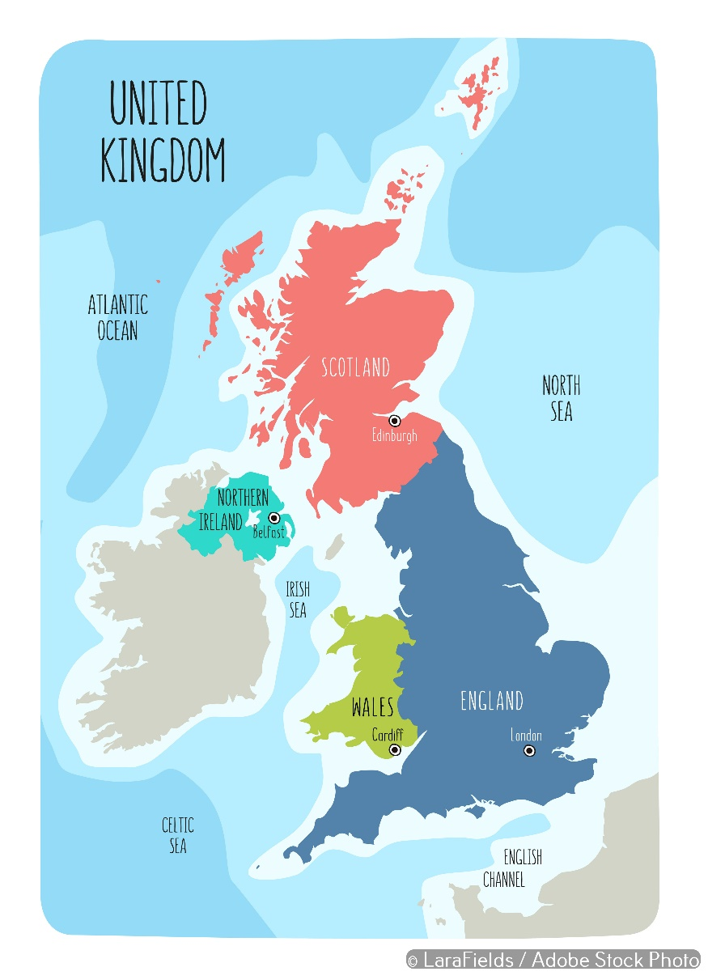

The Snettisham (Iron Age) hoard was found in 1948 in Norfolk.
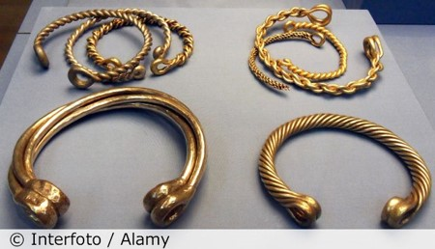

…………………………. is a local Bronze Age site.

…………………………. is a local Iron Age site.

The most important site is ……………………….
because………………………………………………………………………………………………………………………………………………………………………………………………………………………………………………….
The ………………. Age was most impressive because
………………………………………………………………………………………………………………………………………………………………………………………………………………………………………………………………………………………………………………………………………………………………………………………………………………………………………………………………………………………………………………………………
5 words to remember
hoard: a store of money or valuable objects kept somewhere secret
impressive: to have a strong impact, usually positive
interpretation: a description or explanation of something in the past based on sources of evidence
remains: something left over from the past
tribe: a group of people who are of the same kind

Maiden Castle is Britain’s largest hill fort.
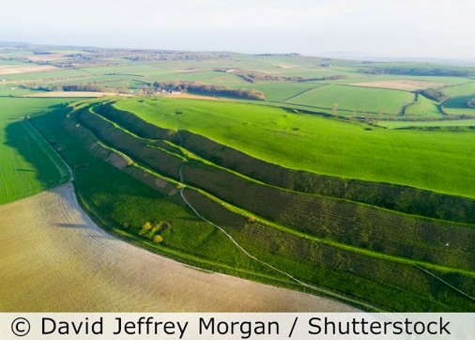
Can you add your location to the map?

The Amesbury Archer was buried near Stonehenge in the early Bronze Age.

