1900
1925
1950
1975
2000
Living memory

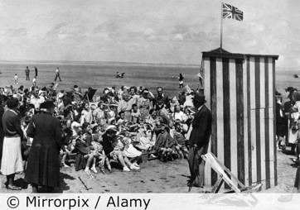
Important things to know
- People began to go on seaside holidays when they started to get paid more money at work.
- In the 1950s, people also began to get more holiday time from work.
- People travelled to the seaside by train or coach. A few people used a car.
- Most people went on holiday in the United Kingdom. Some went to holiday resorts such as Butlins or Pontins.
- Some things about holidays are the same and some are different from the past.
- Not everyone went to the seaside. Some people went camping in the countryside and some people stayed at home.
- We can find out about the past by looking at postcards sent to friends and family.
- We can also ask people about their holidays.
- And we can look at objects people have brought back from their holiday, called ‘souvenirs’.
- We can look at the photographs that people took on holiday too.

Children liked to watch Punch and Judy shows at the seaside.

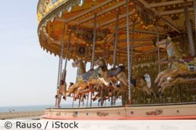

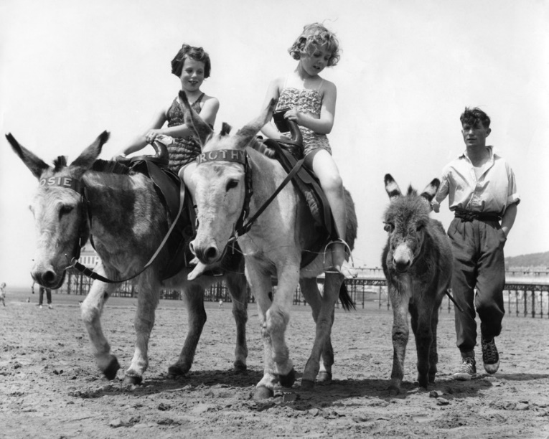
Children liked to ride on the donkeys at the seaside.

Children liked to ride on the carousel at the fairground.

5 words to remember
different
holidays
resort
same
souvenir

The most important change in seaside holidays is…

On their seaside holidays, children today still like to…

