1600
1700
1800
1900
2000
Great Fire of London 1666

Living memory

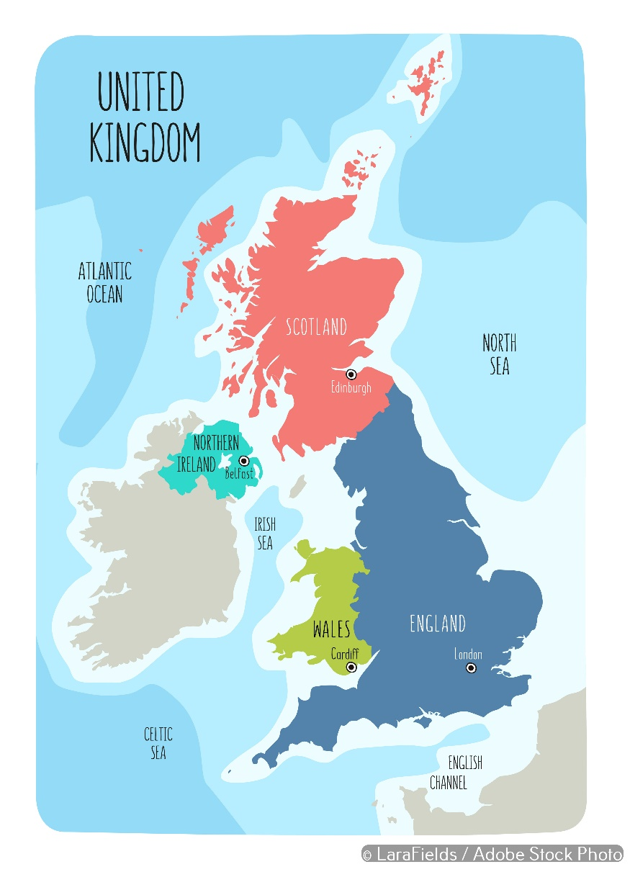

The Great Fire of London by Philippe-Jacques de Loutherbourg. This was painted in 1797, a very long time after the fire took place.

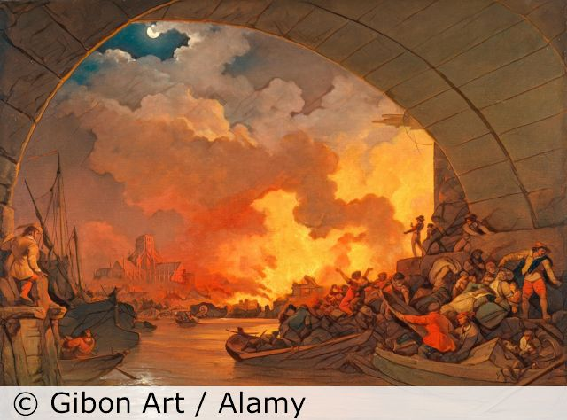
Important things to know
- The Great Fire of London of 1666 happened in the Stuart period.
- It started in a bakery in Pudding Lane, caused by a spark from an oven.
- It lasted for 5 days.
- The fire spread quickly because:
- houses were made of wood and built close together.
- it was very hot. There was no rain.
- there was no trained fire brigade.
- Many houses were burned, and we think 6 people died.
- Samuel Pepys and John Evelyn were eyewitnesses whose diaries tell us about the fire.
- The Monument is a memorial to remind us what happened.
- Sir Christopher Wren planned the rebuilding of London.
- Houses were rebuilt further apart from each other. More were built from brick and stone.
- Fire brigades were set up to stop this from happening again.

Can you find London on the map?
Can you add where you live to the map?
What was happening where you live in 1666?

I think the Great Fire made London a better / worse place because…

5 words to remember
cause
diary
eyewitness
memorial
Stuart

