1800
1850
1900
1950
2000
Living memory

First flight 1903

Rainhill Trials 1829

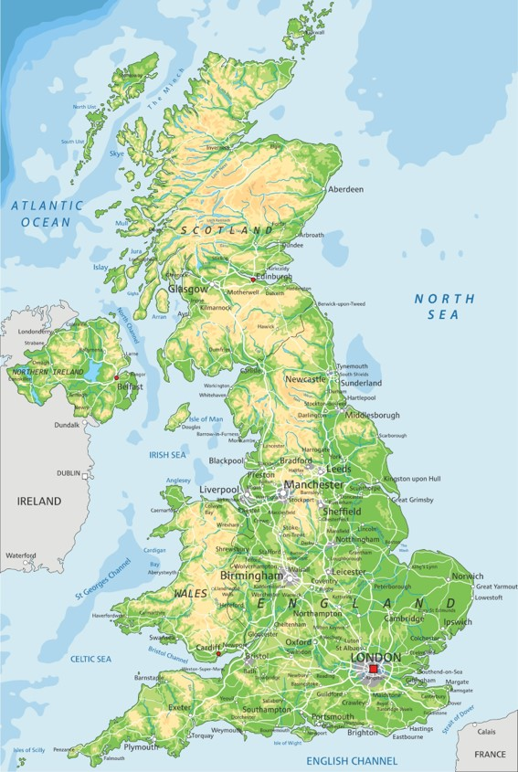
Important things to know
- The Rainhill Trials were a competition to find an engine to carry passengers quickly and safely on the Liverpool to Manchester Railway.
- The course was a 1 mile length of track in Rainhill.
- Robert Stephenson invented the winning train, called the Rocket. It was powered by steam.
- The Rocket was the only train to complete the course without any problems.
- Before the railway, the most popular kinds of transport were by horse or by water.
- Railways were much more popular than canals or rivers as it was easier to choose your route. It was also quicker.
- The Rocket wasn’t the first steam train to be invented.
- We know about the Rainhill Trials by reading newspapers, especially eyewitness accounts.
- We can also find evidence by looking at drawings and objects like the Rocket.
- Today, we use railways to go to work, to have fun and to transport freight to trade with other people and places.

The Rocket was the winning train in the Rainhill Trials, in Lancashire, between Liverpool and Manchester.

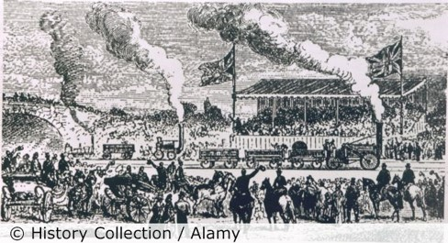

5 words to remember
evidence
eyewitness
invention
trade
transport

One reason the Rainhill Trials were important was that…

Can you add your location to the map?

