1900
1925
1950
1975
2000
Living memory

Important things to know
- You can find out about the recent past by talking to your grandparents. We call this ‘oral history’.
- You can find out what life was like in the recent past through looking at photographs or objects.
- We describe time (chronology), as shown in the timeline above, using special words:
  - Decade is 10 years.
  - Century is 100 years
  - A month has 4 weeks.
  - There are 12 months in a year.
- Many toys today are similar to those played with by grandparents.
- Toys today are usually made from different materials than in the past, for example plastic instead of wood or metal.
- Some grandparents didn’t have the electronic toys you have today.
- Shops today are usually much bigger than when some grandparents were children. We call them ‘supermarkets’ or ‘hypermarkets’.
- Some grandparents mainly learned the ‘3Rs’: reading, writing and arithmetic. You learn about lots of different subjects.
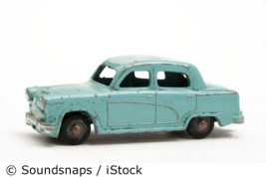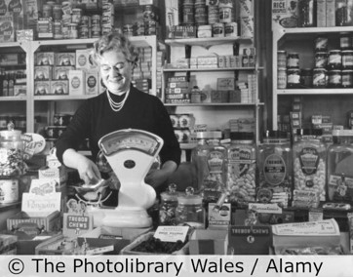

1950s metal toy car

1950s corner shop in Wales

The biggest difference between my grandparents’ childhood and mine is…

5 words to remember
chronology
different
object
similar
timeline

