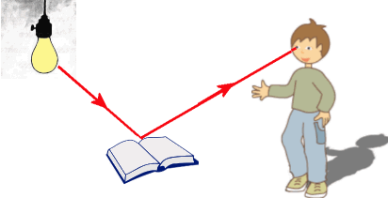
Key Vocabulary
Eyes – Globular organs of sight in the head of humans and vertebrate animals
Filter – Pass through a device to remove unwanted material (liquid, gas, light or sound)
Light – The natural agent that stimulates sight and makes things visible
Light source – Something that provides light, whether it be a natural or artifical source of light (e.g. the sun, a torch)
Periscope – An apparatus consisting of a tube of attached to a set of mirrors or prisms through which an observer can see things that are otherwise out of sight
Rainbow – An arch of colours visible in the sky, caused by the refraction and dispersion of the sun’s light by rain or other water droplets in the atmosphere
Reflection – The throwing back by a body or surface of light, heat or sound without absorbing it
Refraction – The bending of light as it passes from one substance to another with the bending caused by the difference in density between two substances
Shadow – A dark area or shape produced by a body coming between rays of light and a surface
Spectrum – A band of colours, as seen in rainbows, produced by separation of the components of light by their different degrees of refraction

Light
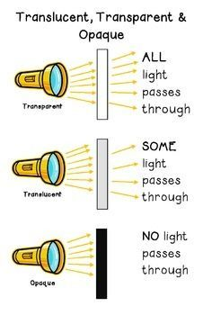

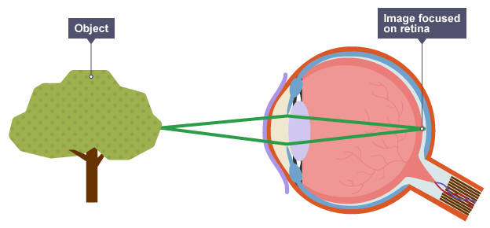
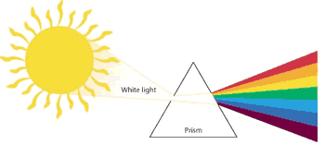

Half-term 1: Light.
- I can use the idea that light travels in straight lines to explain that objects are seen because they give out or reflect light into the eye.

- I can explain that we see things because light travels from light sources to our eyes or from light sources to objects and then to our eyes.

- I can use the idea that light travels in straight lines to explain why shadows have the same shape as the objects that cast them.

Light:
Explain that we see things because light travels from light sources to our eyes or from light sources to objects and then to our eyes
Recognise that light appears to travel in straight lines
Use the idea that light travels in straight lines to explain that objects are seen because they give out or reflect light into the eye
Use the idea that light travels in straight lines to explain why shadows have the same shape as the objects that cast them
Recording data and results of increasing complexity using scientific diagrams and labels, classification keys, tables, scatter graphs, bar and line graphs
Planning different types of scientific enquiries to answer questions, including recognising and controlling variables where necessary
Taking measurements, using a range of scientific equipment, with increasing accuracy and precision, taking repeat readings when appropriate

