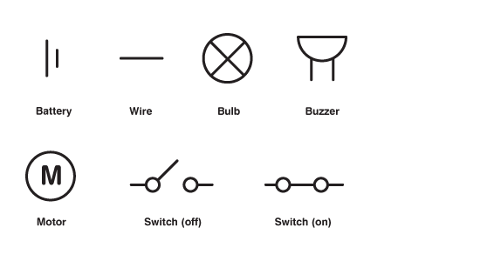

**Key Vocabulary**

**Battery – A container consisting of one or more cells where chemical energy is converted into electricity and used as a source of power**

**Bulb – A glass bulb which provides light by passing an electrical current through a filament**

**Buzzer – An electrical device that makes a buzzing noise and is used for signalling**

**Cell – A device containing electrodes that is used for generating current**

**Circuit – A complete and closed path around which a circulating electric current can flow**

**Conductor - A material or device which allows heat or electricity to carry through**

**Current – A flow of electricity which results from the ordered directional movement of electrically charged particles**

**Electricity – A form of energy resulting from the existence of charged particles**

**Filament – A conducting wire or thread with a high melting point that forms part of an electric bulb**

**Motor – A machine powered by electricity that supplies motive power for a vehicle or other moveable device**

**Switch – A device for making and breaking the connection in an electric circuit**

**Voltage – An electrical force that makes electricity move through a wire, measured in volts**

**Electricity**

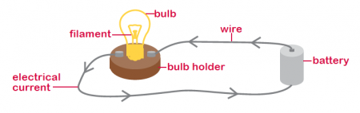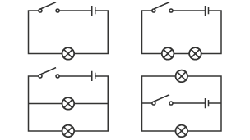

Key Skills: Circuits.

Associate the brightness of a lamp, speed of motor or volume of a buzzer with the number of and voltage of cells used in the circuit.

Compare and give reasons for variations in how components function, including the brightness of blubs, the loudness of buzzers and the on/off position of switches.

Use recognised symbols when representing a simple circuit in a diagram.

